FUNTHINK TEACHER MANUALS PRIMARY EDUCATION
MODULE 1: VARIATION-CO-VARIATION

Overall learning objectives of primary school / teacher education:

Quantitative reasoning:

What are the quantities that vary?
  - How do the quantities co-vary?
  - How do they correspond?
  - Object view
- Representations of functions (adaptive expertise/fluency)
  - Moving between representations (table/graph/numbers/map/story)
  - Linking representation and situation

These learning objectives come to the fore in three modules:

- Variation-co-variation
- Distance-time graphs
- Patterns

Each of these modules consist of a learning trajectory with the following characteristics:
Students…
- ...experience covarying quantities
- ...identify co-varying quantities; track them
- ...explain how they relate
- ...describe the correspondence
Key principles with each of these modules are variables, relationships, and generalization; key processes are noticing, describing, justifying, representing, generalizing, reflecting and applying.

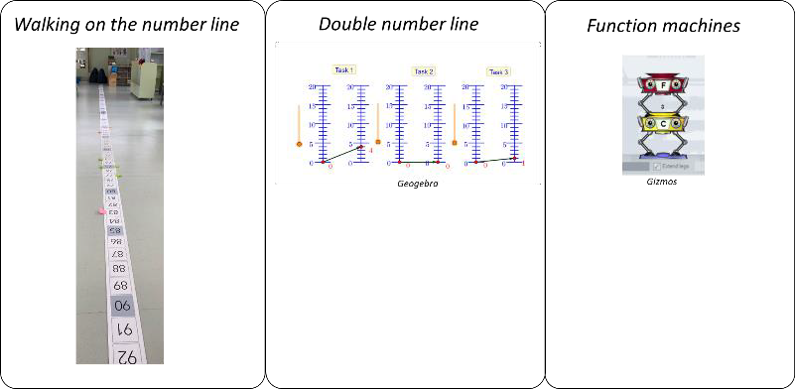
In this document you can find the teacher manual of Module 1: variation-co-variation. This module consists of three main activities:

Walking on the number line
- Double number line
- Function machines

Lesson Plan Module 1

Module: | Variation-co-variation:  - Lesson 1: Walking the number line  - Lesson 2: Double number line  - Lesson 3: Function machines
Teaching Hours: | 3 x 1 hour
Grade Level/Age Range: | 4-6 (9-12 years old)
Brief Description: | In Module 1, students first explore the number line (Lesson 1). Students walk on the number line to find so-called secret rules (functions). By developing strategies to find these secret rules and by representing their reasoning, students gain understanding about functions. They work with different kinds of relations (additive, multiplicative, single operation, multiple operations). Students then move to the double number line (Lesson 2). Thus, they first engage with physically enacted co-variation on one number line and then with co-variation of quantities on two number lines in a tablet application. They are asked to explore how quantities vary, how the variation of one quantity affects variation in the other quantity, and to identify and express the relation that shows how one quantity corresponds to the other. Students then proceed with exploring function machines (Lesson 3). Function machines can help students understand the input-output aspect of functional thinking and explore relationships between pairs of numbers. Students identify the rule that links the input with the output values, create their own function machines to produce given tables, and examine function composition. Thus, also working on correspondence relations and first steps towards the object view of functions.
Design Principles: | Inquiry
 | Situatedness
 | Digital tools
 | Embodiment
- Inquiry based learning: find the secret rules (functions) through inquiry; explore relationships;
- Situatedness: Students recognize the game element in the activities; build on students’ intuitive knowledge and daily life experiences with games
- Digital: transfer from physical activities to a digital activity
- Embodiment: While walking the number line, students connect their own physical movement to that of the other student and perceive the relation between their positions (perceptual-motor experiences). This provides a physical reference for and extends to movement in a digital environment.
Functional Thinking: | Input – Output
 | Covariation
 | Correspondence
 | Object

Learning Goals: | Quantitative reasoning:  - Students experience covarying quantities  - Students discover relationships between numbers based on a ‘secret’ function  - Students identify, generalize and express additive and multiplicative linear relations  Representations of functions:  - Students conceptualize intuitive the idea of functions  - Students identify, generalize and represent additive and multiplicative, linear relations  - Students use functions to represent input-output relationships  - Students represent (verbally, symbolically and graphically) relations between quantities and move between representations (table, graphs, story, numbers)

Activities

Walking the number line

Divide the students into two groups of 10-15 students. One group remains in the classroom and does regular work, while the other group performs the activity elsewhere. After twenty minutes their roles change, so the group that remained in the classroom walks on the number line and vice versa. Twenty minutes later the entire class joins the classroom discussion with the teacher in the classroom.
This activity helps students explore the input-output aspect of functional thinking and the relationship between pairs of numbers. Students identify the rule that links the input with the output values.

Introduction

The teacher places the number line in front of a group of students, preferably not in the classroom, and explains the activity. The teacher demonstrates an example with student volunteers. The teacher explains that students will work in pairs. One pair of students will get a card with a secret rule (an operation, e.g. “+2”) on it. The other pair of students will need to work out what the secret rule is. by walking along and standing on the number line.
Then, as an example, the group of students plays the game once. The teacher shows a card with a rule (e.g., ‘+2’; always start with a simple addition problem) to all students but not to himself/herself. The teacher has to discover the rule. The teacher stands on the number ‘1’ on the number line, and sticks a sticky note on that number. The students (who know the secret rule) walk to the outcome of their secret rule (When ‘1’ is the input for the calculation, they stand on ‘3’), and stick a sticky note on that number. The teacher then reasons out loud to figure out what the secret rule could be. The teacher proposes different possible rules, but needs more information to be sure. This is a step similar to data gathering, and forming hypotheses. The teacher then walks to another number on the number line, which leads to the students walking to the new output number (on both numbers a new sticky note is stuck). This is a step of verification. The teacher then explains how they know the rule and shares it with the students.
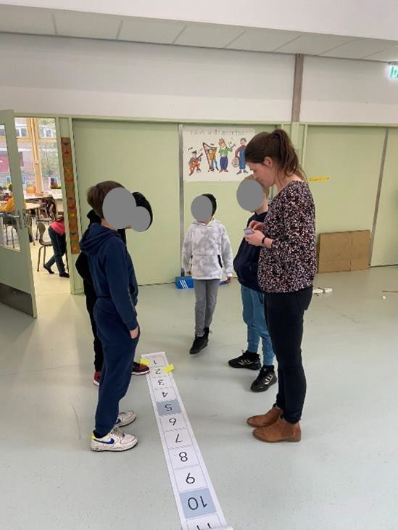
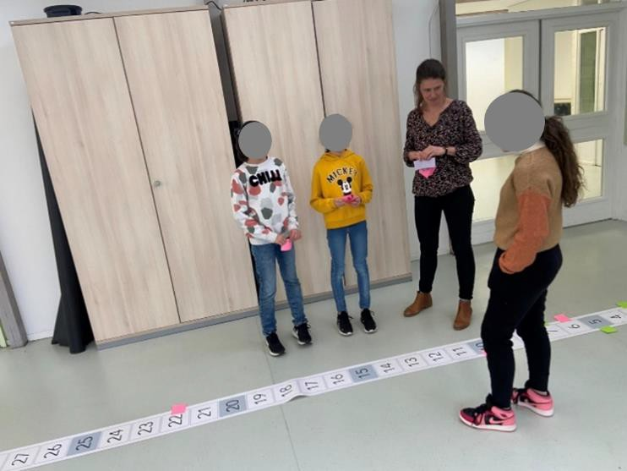

The teacher explains that the roles of the pairs of students will be switched around each time: after discovering a secret rule, the roles switch and the other pair of students has to discover the rule. The students are divided into groups of four (two pairs of students) and play the game together. After each pair of students has played both roles (knowing and discovering), the group of four students together make a poster of their findings. The poster reflects the reasoning of the students.

Suggested tools/materials/:
- Two (or three) physical number lines from 1-100, so that about 12-15 students can work on them concurrently. Preferably in steps of 1 to clearly visualise the students’ steps.
- Cards with the ‘secret rules’ on them. Addition (+1 until +9), subtraction (-1 until -9), multiplication (x2 until x5) and division (:2 until :5)
- Sticky notes in different colours
- Blank A3 sheets
- Pencils in different colours

Estimated duration: 5 minutes

Walking the number line

After the whole class introduction, the students do the activity. In small groups, students take turns to knowing or discovering the rule. After each pair of students has played both roles (knowing and discovering), the group of four students together make a poster of their findings. The poster has to reflect the reasoning of the students.
The teacher walks around to guide the students. The teacher hands out the cards in the following order:
  - Singular addition or subtraction problems (e.g., +2, -4).
  - Simple singular multiplication problem (e.g., x2, x3)
  - Simple composed problems, combining addition and multiplication (e.g., x2 +1)
  - More difficult composed problems, combining all types of operations (e.g., :3 – 4)
Moreover, the teacher walks around, observes, and asks questions like:
- Are you sure? Why (not)?
- How can you find out?
- How do you know?
- Why do you choose this number?
The teacher also encourages students to make a poster of their findings.

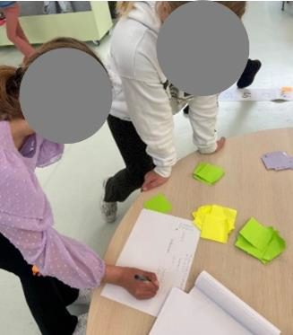
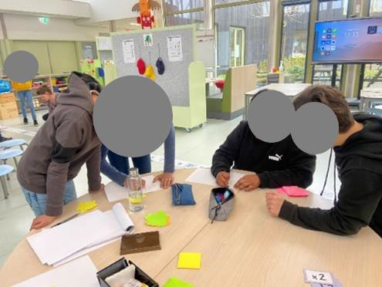
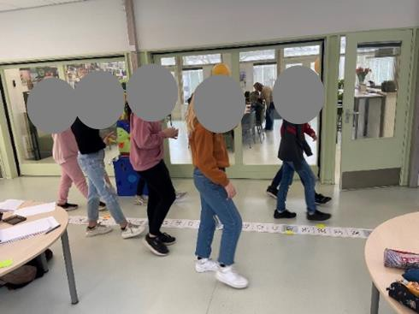
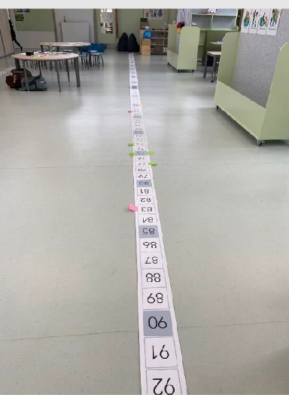
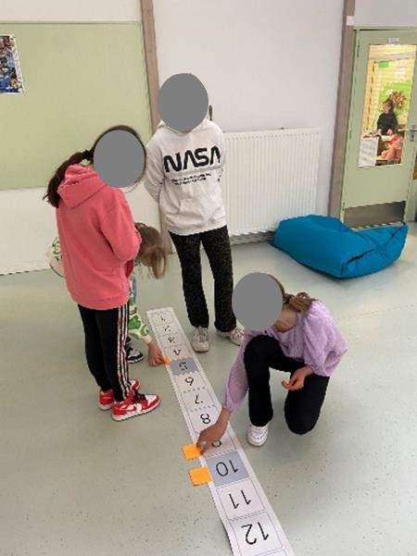
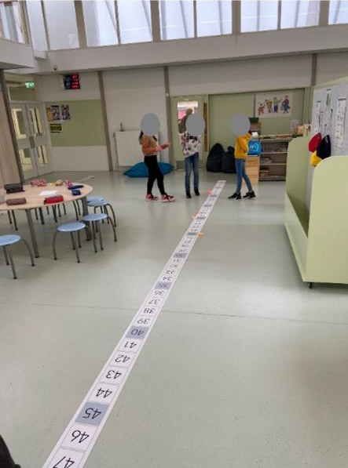
By using the sticky notes, the pattern of the input-output combinations becomes visible for students and teacher to inspect:
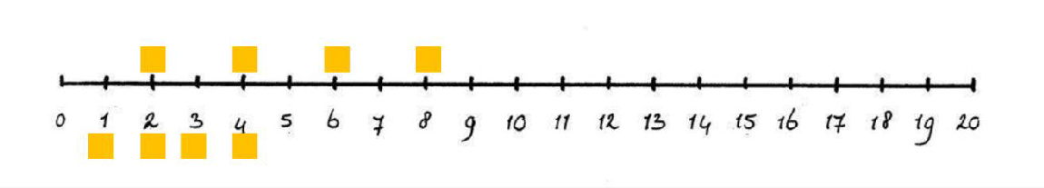
Suggested tools/materials:
- Two (or three) physical number lines from 1-100, so that about 12-15 students can work on them concurrently. Preferably in steps of 1 for clear visualisation of the steps of students.
- Cards with the ‘secret rules’ on them. Addition (+1 until +9), subtraction (-1 until -9), multiplication (x2 until x5) and division (:2 until :5)
- Sticky notes in different colours
- Blank A3 sheets
- Pencils in different colours

Estimated duration: 15 minutes

Whole classroom discussion

During the whole classroom discussion, the teacher guides the reflection on the activity. The posters that were made by the students can serve as a starter for the conversation. The teacher asks questions on how the students experienced the activity and what strategies they used to discover the secret rule. For example, with what number did they start, and why? What did they do to discover the secret rules? Which strategies did they use? How many options were possible?
In order to understand the thinking processes of the students, the teacher proposes to find a secret rule (in the mind of the teacher) together. One student offers the first (input) value; the teacher writes down the output value. Here the teacher does not use a physical or schematic number line anymore, but a more abstract representation such as, for example, a table with rows and columns. After one input and one output value (e.g., 4 and 20), the teacher asks which student knows the secret rule. Students will likely come up with various options (e.g., +16, x5, x2 + 12, x6 – 4); the teacher notes down all the alternatives and asks the students how they can find out which one best fits the numbers they have. The whole group together then tries another (input) value, the teacher writes down the outcome (output) value and all options are checked.
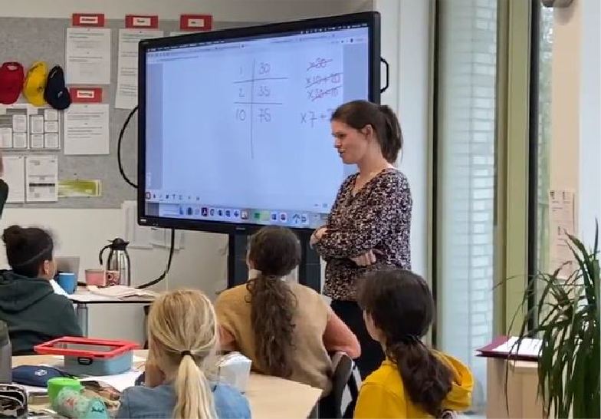

Suggested tools/materials:
- Posters created by the students
- Whiteboard
Estimated duration: 15 minutes

Double number line
During this classroom activity students will explore the relationship between two variables in a virtual environment with two number lines. Students explore how quantities vary and how the variation of one quantity affects variation in the other quantity.
This activity serves in understanding the input-output as well as the covariation aspect of functional thinking and exploring the pairs of numbers. Students identify the rule that links the input with the output values and explore how one varying quantity affects the other.
Introduction
The teacher starts by recalling the activity of walking on the number line. What was the goal of the activity (discovering the secret rule)? And in what way could this goal be achieved (trying different values and exploring the effect)?
The teacher then explains that a similar activity will be performed today. Only this time students will not walk themselves. Instead, they can will ‘create simulate movement’ in a virtual environment.
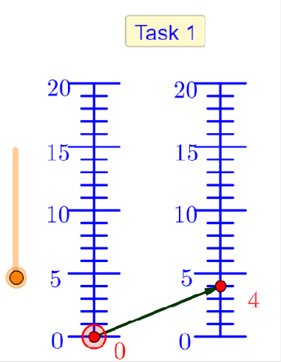
The teacher starts with opening opens the GeoGebra application with Tasks 1-3 (https://www.geogebra.org/m/vsgqkkz3). The teacher shows that by dragging the red point on the left axis of the double number line or by dragging the orange button, the numbers on the left axis of the double number line change. Meanwhile, the numbers on the right axis of the double number line also vary. The teacher discusses with the students the differences and similarities between Task 1 in the digital environment and the activity of walking the number line.
Similarities:
- Number line
- You change one value and the other value changes as a response
- …
Differences:
- One number line with values on each side vs. two number lines
- Range of numbers 0-100 vs. range 0-20
- Only whole numbers are visible vs. also decimal numbers
- Only positive numbers vs. also negative numbers (tasks 4-6)
- …
Suggested tools/materials:
- GeoGebra application double number line tasks 1-3: https://www.geogebra.org/m/vsgqkkz3
- Beamer to project the application
Estimated duration: 10 minutes
Double number line: discover the secret rules
Students then work in pairs with the application. Students are asked to drag the red dot on the left axis of each double number-line and observe how the arrow on the right axis moves. They start with tasks 1-3 and once finished continue with tasks 4-6.
In total, students work on six tasks with the following hidden functions:

Task 1 | +4 | Task 4 | x2 +1
Task 2 | x2 | Task 5 | x3 -5
Task 3 | x2 +1 | Task 6 | x2 -8

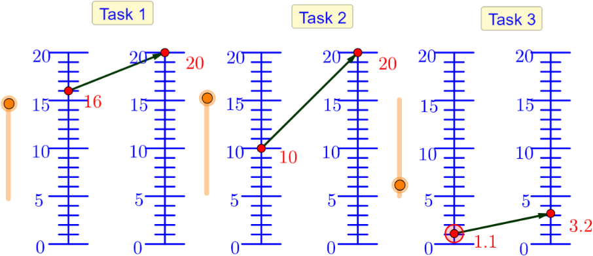
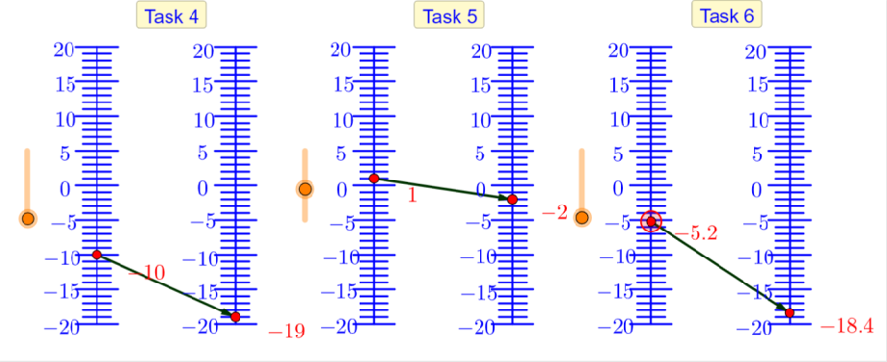

Students’ task is to discover the secret rules. During the activity, students are asked to keep track of what they discover, for example by writing down different values they tried in a table.
The teacher walks around and asks questions with the aim to elicit students’ exploration and
reflection. Questions such as:
- Are you sure? Why (not)?
- How can you find out?
- What strategies can you use?
- What strategies did you use on the physical number line?
- How do you know?
- Why do you choose this number?
During the activity the teacher constantly refers to the students’ experiences with walking the number line.

Suggested tools/materials:

Tablets for each pair of students
- Double number line tasks 1-3: https://www.geogebra.org/m/vsgqkkz3
- Double number line tasks 4-6: https://www.geogebra.org/m/m7bn4s9j

Estimated duration: 30 minutes
Whole classroom discussion

During the whole classroom discussion, the teacher guides the reflection on the activity. The teacher and students look at one or two tasks together. The teacher asks questions on what strategies the students used to discover the secret rules. With what number did they for example start, and why? Did they make use of the line between the numbers? What did they do to discover the secret rules? Which strategies did they use? How many options were possible? How did you check your answers? How did you keep track of your reasoning? What did you write down?
Finally, it is also interesting to ask how the students experienced the activity.

Suggested tools/materials:

Tablets for each pair of students
- Beamer to project the application

Estimated duration: 20 minutes

Function machines
During this classroom activity students will explore the relationship between two variables in a virtual environment with function machines.
Function machines help understand the input-output aspect of functional thinking and exploring pairs of numbers. Students identify the rule that links the input with the output values and create their own function machines to produce given tables.

Introduction
The teacher starts by recalling the activity of walking on the number line and the activity of the virtual double number line. What was the goal of the activity (discovering the secret rule)? And in what way could this goal be achieved (trying different values and exploring the effect)?
The teacher then explains that a similar activity will be performed today. Only this time students will not use number lines. Instead, they will work with special ‘machines’ which are created to execute specific rules.
The teacher starts with opening the GeoGebra application with the function machines 1-4 (https://www.geogebra.org/m/e4zuj5ss). The teacher opens function machine 1. The teacher shows that you can ‘put a number in the machine’, that the machine makes a ‘calculation according to the secret rule’, and then shows the outcome value. The teacher asks the class with which number they would like to start. The teachers fill in the number in the box ‘input’ and watches what happens with the output (secret rule = +5). The teacher puts both number in a table or a similar representation (e.g., 2 → 7). The teacher asks student which secret rule they assume is correct and writes down all possibilities given by the students. The teacher then asks how we could check with alternative is correct. Together the teacher and the students try another value and find out which rule is correct.
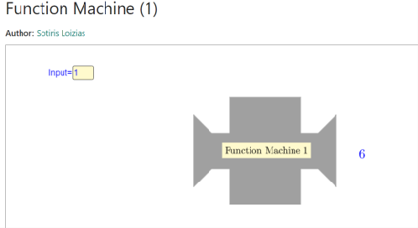

Suggested tools/materials:
- Geogebra application function machines (https://www.geogebra.org/m/e4zuj5ss).
- Digiboard to project the application

Estimated duration: 10 minutes
Function machines – Part 1
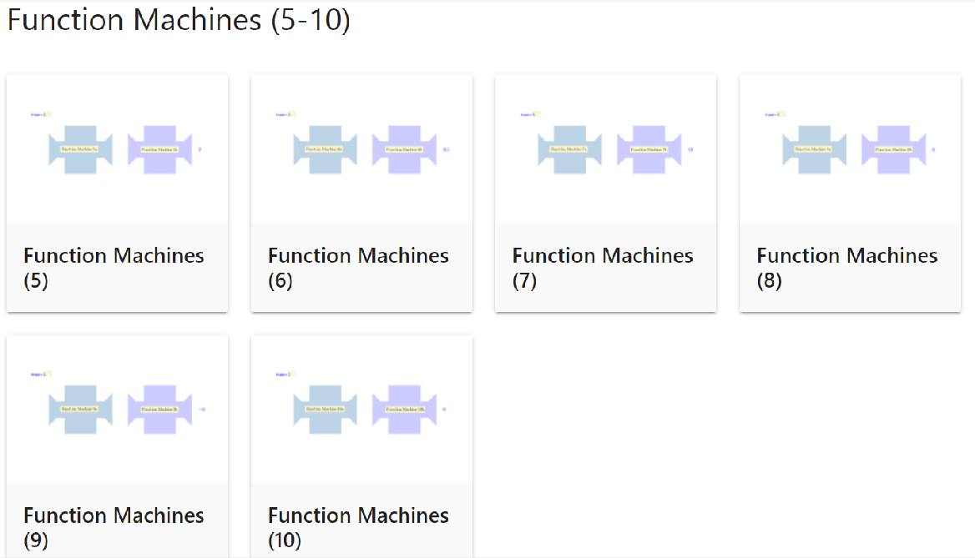
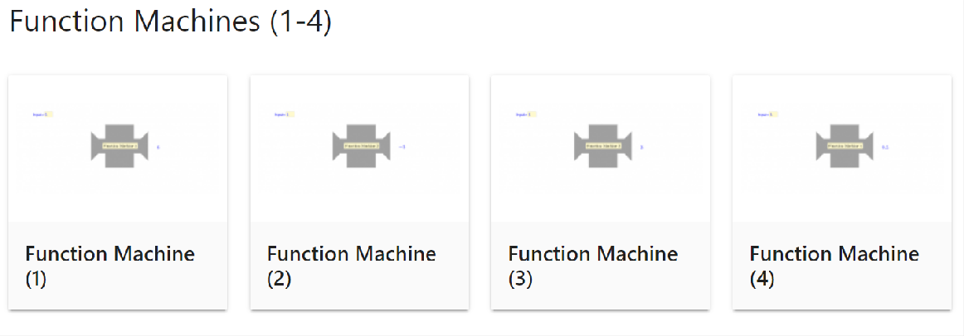
From this point on, students can work in pairs with the function machines and proceed with tasks 2 till 10 until the time is finished. Each task they have to discover another secret rule. Students are encouraged to take notes each task.
Tasks 1-4 are singular problems and tasks 5-10 are composed problems. In total, students work on ten tasks with the following hidden functions:
Machine 1 | +5 | Machine 6 | :2 +3
Machine 2 | -4 | Machine 7 | +4 x2
Machine 3 | x3 | Machine 8 | x2 +4
Machine 4 | :2 | Machine 9 | -3 x3
Machine 5 | +3 :2 | Machine 10 | x3 -3

During this activity, the teacher walks around, observes, and asks questions like:
- Are you sure? Why (not)?
- How can you find out?
- What strategies can you use?
- What strategies did you use on the physical number line or the double number line?
- How do you know?
- Why do you choose this number?
During the activity the teacher constantly refers back to the students’ experiences with walking the number line and the experiences in the digital environment with the double number line.
Please note that, since the composed function machines consist of two separate operations, the order in which the function machines execute the operations does not necessarily follow the standard procedures for the execution of mathematical operations. For example, function machine 5 first adds 3 to the input number and then divides the outcome by 2 (in short: +3 :2). According to the standard procedures of the execution of mathematical operations, where division precedes addition, this should be the other way around. Please, discuss this discrepancy with students when necessary.
Suggested tools/materials:
- Tablets for each pair of students
- Function machines tasks 1-10 (https://www.geogebra.org/m/e4zuj5ss).

Estimated duration: 15 minutes including classroom discussion
Whole classroom discussion – part 1
During the whole classroom discussion, the teacher guides the reflection on the activity. The teacher and students look at one or two tasks together. The teacher asks questions on how the students experienced the activity and what strategies the students used to discover the secret rules. With what number did they for example start, and why? Did they make use of the line between the numbers? What did they do to discover the secret rules? Which strategies did they use? How many options were possible? How did you check your answers? How did you keep track of your reasoning? What did you write down?
The teacher also discusses the differences between tasks 1-4 (singular problems) and tasks 5-10 (composed problems). Moreover, the teacher discussed the differences and similarities between this task with the function machines and the previous two other activities of walking the number line and the double number line (e.g., for the composed functions, the function machines show the intermediate answer whereas the number lines do not).
Suggested tools/materials:
- Tablets for each pair of students
- Function machines tasks 1-10 (https://www.geogebra.org/m/e4zuj5ss).

Estimated duration: 5 minutes
Function machines – Part 2
Introduction: For part 2 of the activity, the teacher shows function machines 11 and 12. The teacher explains that now students can create their own machines. The teacher shows how to change the ‘secret rule’ of the function machines and explains (in Dutch) what addition (+), subtraction (-), multiplication (x) and division (-) means.
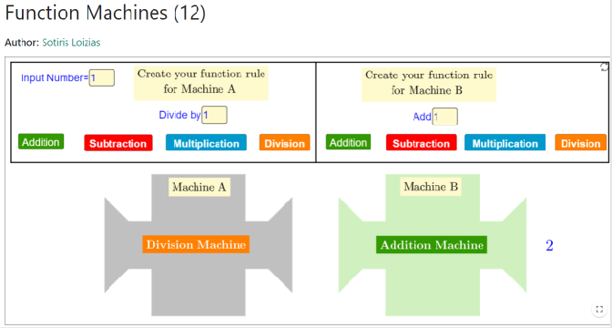
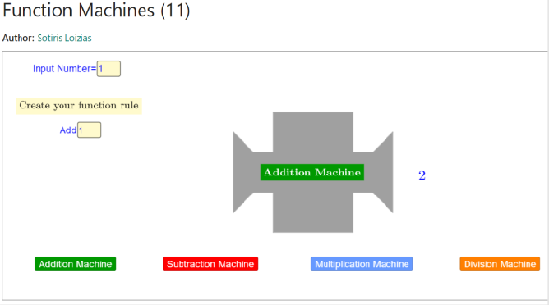

The teacher then writes down the following pair of numbers on the whiteboard:
4 | 13
Students’ task is now to come up with different function machines which have an input value of 4 and an output value of 13 (e.g., +9; x2 +5; x4 -3). Students mention alternatives and the teacher and the students together build the function machines. After this example, each pair of students gets two pairs of values for which they have to come up with as many function machines as possible.
Task 1:
3 | 15
Task 2:
4 | 6
During this activity, the teacher walks around, observes, and asks questions like:
- What strategies do you use?
- How can you find out if this machine is correct?
- Are you sure? Why (not)?
- How do you know?
Suggested tools/materials:
- Tablets for each pair of students
- Function machines tasks 11-12 (https://www.geogebra.org/m/e4zuj5ss).

Estimated duration: 20 minutes (including introduction)

Whole classroom discussion – part 2
During the whole classroom discussion, the teacher guides the reflection on the activity. The teacher and students look at one of the two tasks together. The teacher asks questions on how the students experienced the activity and what strategies the students used to come up with as many alternatives as possible. Which strategies did they use? How many options were possible? How did you check your answers? Is there a limitation in possibilities? Why(not)?
Suggested tools/materials:
- Tablets for each pair of students
- Function machines tasks 11-12 (https://www.geogebra.org/m/e4zuj5ss).

Estimated duration: 10 minutes

