Lesson Plan

Module: | Qualitative interpretation of Graphs
Teaching Hours: | 3 x 40 minutes
Grade Level/Age Range: | Grades 5-6 (10-12 years old)
Brief Description: | Students use graphs to model real-life scenarios, interpret intuitively how changing a graph modifies the quantities involved in a real-life scenario and represent linear relations.
Design Principles: | Inquiry
 | Situatedness
 | Digital tools
 | Embodiment
- Meaningful: Build on students’ intuitive knowledge and daily life experiences with real-life scenarios
- Embodiment: Perceptual-motor (action-perception) experiences with noticing the impact of changing the values of sliders on graphs, grounding the understanding of the relation between the involved quantities (gradient and y-intercept) with concrete actions
- Inquiry based learning: explore qualitative interpretations of graphs
- Digital: tablet devices equipped with appropriate apps
- Didactical phenomenology / situatedness: modeling of real-life scenarios through changing the parameters of linear relations
Functional Thinking: | Input – Output
 | Covariation
 | Correspondence
 | Object
Learning Goals: | - Model real-life scenarios using graphs  - Explain how changing the y-intercept of a graph and its steepness modifies the quantitative relations of a real-life scenario  - Pose problems based on graphs that represent linear relations

Activities

Exploration 1
The teacher shows the following graph from the GeoGebra app (Interpretation of Graphs (1) – GeoGebra) in whole class. The graph represents how a taxi company calculates its charge.
Teacher’s questions:
- What do the horizontal and the vertical axis represent?
- What is the total charge for 3, 5, 7 km?
- What is the charge for every extra km?
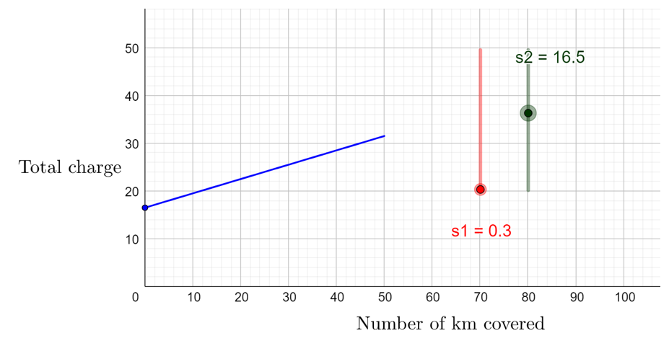
- What does the point (0, 2) represent?

Students drag the two sliders and make hypothesis about the role of each slider. Students explain how changing the value of each slider modifies the way that the total charge of the taxi is calculated.
- Whole-class discussion: How is the total charge calculated? How each parameter of the total charge is expressed in the graph?
- The following questions could also be used: (a) How increasing the flat charge of each ride could be modelled using the graph? (b) How increasing the charge for an extra km could be modelled in the graph? (c) How would the graph change if the taxi company eliminated the flat charge?
Suggested tools/materials: GeoGebra app
Estimated duration: 15 - 20 minutes

Exploration 2
Students are introduced in a real-life scenario. A GeoGebra app with 3 graphs is shown (Interpretation of Graphs (2) – GeoGebra). Students drag the two sliders of each graph to model accurately each offer. Students are asked to explain what the horizontal and vertical axes represent. They also make initial hypothesis individually and then compare their ideas in groups.
Students may be prompted to find the total cost for a certain number of guests for each offer. They are also asked to compare the three offers using the respective graphs and decide for what number of guests each offer should be chosen.

Suggested tools/materials: Tablet Devices, GeoGebra App
Estimated duration: 15 - 20 minutes

Activities

A GeoGebra graph is provided. Students set the two sliders to represent the offer for Playground D. One slider defines the cost for each guest up to 20 persons and the second one the cost for each guest for values greater than 20 persons.
Students experiment with the sliders to model the situation and describe the shape of the graph. They make initial hypothesis individually and then compare their ideas in groups. During the whole-class discussion, emphasis is placed on how the reduction of the cost for additional guest changes the steepness of the graph.
After finding the y-value for certain x-values, students are asked to use the graph to solve an inequality: find the x-value that gives y-value smaller than 300.
In the final stage of the activity, students discuss how changing the cost for additional guests affects the steepness of the graph.
Suggested tools/materials: Tablet Devices, GeoGebra App, Students Handout
Estimated duration: 40 minutes

Students are asked to describe the offer from two additional playgrounds using their respective graphs. In this activity, students extend their understanding from Activity 1.
In the following graph, students would notice the following:
Until 7 guests, the cost for each additional guest is 15 euro and there is no fixed cost. When the number of guests is greater than 7, the cost for an additional guest is 10 euro. Students may be prompted to explain how the change of the cost for each additional guest is represented in the graph, by making links to the change of its steepness at the point (7, 105).
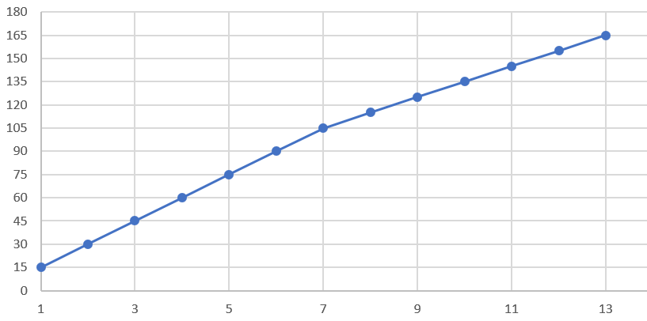

In the following graph, students would notice the following:
The cost for zero number of guests is 30, thus, there is a fixed cost of 30 euro. Then, students should coordinate the difference in the number of guests to the difference in the total cost (covariational reasoning) to calculate the cost for each additional guest. Example of question: What is the difference in the total cost for 5 and for 6 guests?
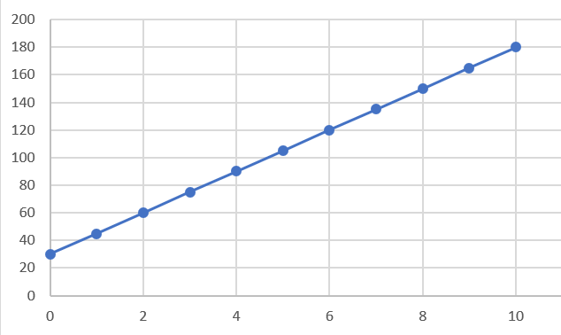

Suggested tools/materials: Tablet Devices, GeoGebra App, Students Handout
Estimated duration: 15 minutes

Students drag the sliders to create the graph that corresponds to each situation in the Geogebra App. Students emphasize the qualitative interpretation of each situation and are prompted to explain what each axis represents in each situation.

Situation 1: Students show the connection charge as the intercept point on the vertical axis.
Situation 2: Students show number 17 as the y-intercept and a decreasing line.

Situation 3: Students show the service call as the intercept point on the vertical axis and an increasing line.
Situation 4: Students show the initial value of 1200 as the y-intercept and a decreasing line.

Suggested tools/materials: Tablet Devices, GeoGebra App, Students Handout
Estimated duration: 25 minutes

Extension Activities

Activity 1.
Students are asked to alter the story in two of the four scenarios of Activity 3, make the necessary changes in the sliders, and draw a rough sketch of the new graph. Emphasis will be placed on the qualitative interpretation of the changes and how the change in the scenario changes the graph.

Activity 2.
Students study the graph and find the covariational change for values of x up to 5 and then for values of x greater than 5.
Then, they drag the sliders to model the graph in the app. The most demanding part of the task is to provide a real-life scenario that corresponds appropriately to the graph. Students are expected to use identified covariational values in their description.
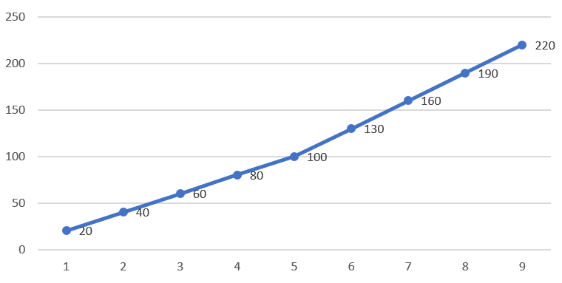

Assessment Activities

The provided assessment activities refer to the following levels of sophistication:
- Processes – Students use the graph to find y-values for given x-values and vice-versa
- Problem solving – Students match the verbal description of situation with the graphical representation
- Reasoning – Students describe real-life situations based on the given graphs, taking into consideration the involved quantitative relations.

1. The following graph shows how a taxi company calculates the charge per km covered.
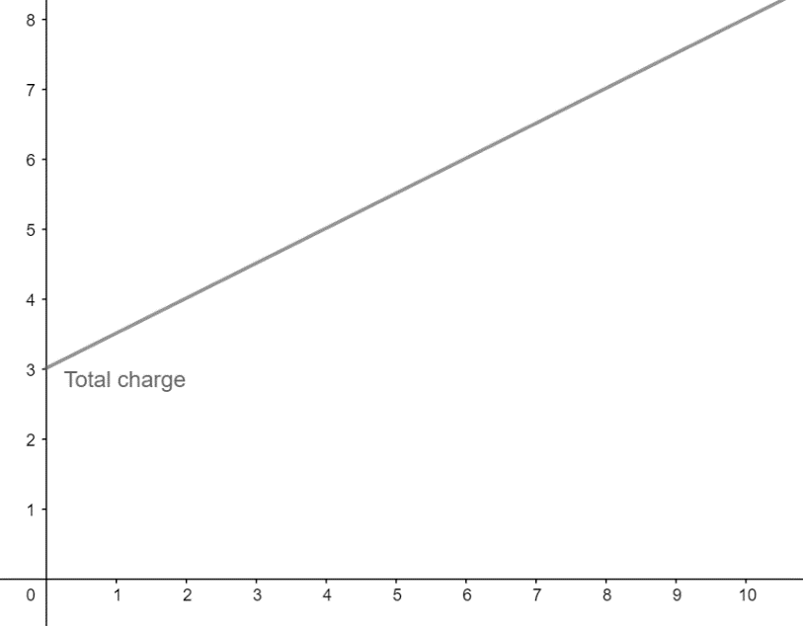

- What is the charge for a 5 km drive?

- What is the extra charge for each additional 1 km drive?
- John paid €7. How many km did he cover?
- Anna paid €3. What happened?

2. Match each situation with the corresponding graph.
Description | Graph
A plumber charges based on the following plan: A flat cost of €20 for a service call and an additional charge of €30 per hour.

At a gas station the price of petrol is €1,38 per litre.
An offer for a birthday party charges €14 per guest. In the total cost a discount of €40 is applied. | 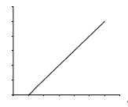

3. Study the following 3 graphs and describe a real-life scenario that corresponds to each graph.

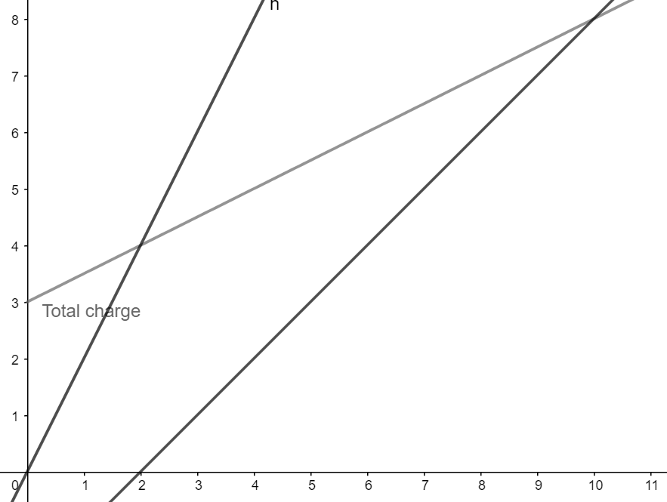

Digital Tools:
Exploration 1:
https://www.geogebra.org/m/ha5apawu
Exploration 2:
https://www.geogebra.org/m/fahmmmrt
Activity 1, 2, 3:
https://www.geogebra.org/m/gvqwnten

