Module: Qualitative Interpretation of Graphs
Exploration 1
How do taxis charge?
The following graph shows how a taxi company calculates its charge. The horizontal axis represents the number of kilometers covered and the vertical one the total charge.
Drag the sliders to explore how the total charge changes. Explain how increasing/decreasing the value of each slider changes the way the total charge is calculated.
Interpretation of Graphs (1) – GeoGebra
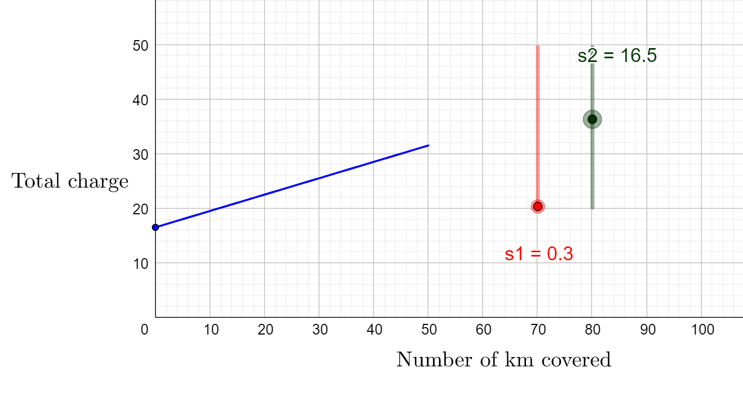

Exploration 2

Read the following scenarios:
Helen wants to organize her birthday party in a playground. She is studying the following offers:
- Playground A:
The cost for each guest is €15.

- Playground B:
The cost for each guest is €12. An additional fixed cost of €50 should be paid.

- Playground C:
The cost for each guest is €18. A discount of €30 will be provided in the final total cost.
Helen constructed graphs to model the three offers. Drag the sliders to explore how the graph changes. https://www.geogebra.org/m/fahmmmrt

- What do the vertical and the horizontal axis represent? Explain.
- Set the sliders of each graph to represent the offers. Explain.
- Compare the three graphs to find out which one is the best.

Activities:

Helen asked for an addition offer from Playground D.
Interpretation of Graphs (3) – GeoGebra
- Playground D:
The cost for each guest is €17, up to 20 persons. The cost for any additional guest will be €10.

- Drag the sliders in the app to model the offer from Playground D.

- Describe the shape of the graph.

- Based on the graph, answer the following:
  - What is the cost for 8 guests?

  - What is the cost for 15 guests?

  - What is the cost for 25 guests?

- Helen’s budget cannot exceed €300. What is the maximum number of guests for her party?

- How will the graph change if the charge for any additional guest is €20 instead of €10? Explain.

Check your answer.

The following graphs present the offer from Playground E and F. Describe in words their offer.

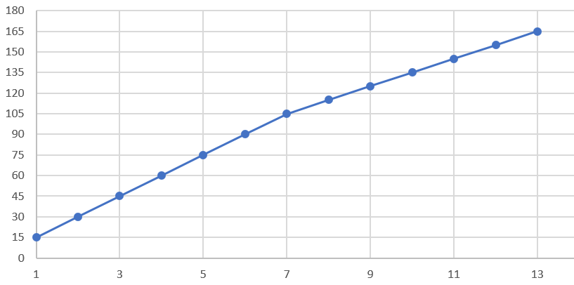
Playground E: Total charge per number of guests

……………………………………………………………………………………………………………………………………………………………………………………………………………………………………………………………………………………………………………………………………………………………………………………………………………………………………………………………………………………………………………………………………………………………………………………………………………………………………………………………………………………………………………………………………………………………………………………………

Playground F: Total charge per number of guests
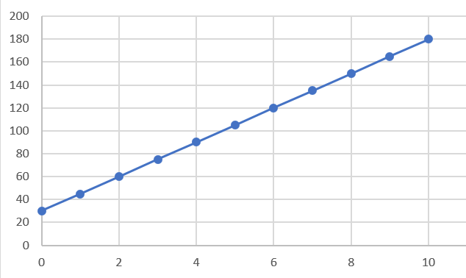

………………………………………………………………………………………………………………………………………………………………………………………………………………………………………………………………………………………………………………………………………………………………………………………………………………………………………………………………………………………………………………………………………………………………………………………………………………………………………………………………………………

Drag the sliders in the Geogebra app to model the following situations. Explain the shape of each graph.

Situation 1:
George’s electricity company charges him €0,11 per kWh (kilowatt-hour) of electricity, plus a basic connection charge of €15.00 per month. How is the total charge of the month calculated?

Situation 2:
The water level of a river is 17 meters. It is receding at a rate of 0,25 meter per day. What is the water level of the river after a number of days?

Situation 3:
A plumber charges €25 for a service call plus €50 per hour of service. How his total charge is calculated?

Situation 4:
Tim buys a new computer for his office for $€$1200. For tax purposes, he declares a linear depreciation (loss of value) of €150 per year. How is the value of the computer calculated after a number of years?

Extension Activities:

Activity 1
For two of the four scenarios of Activity 3, change the story, make the necessary changes in the sliders and make a rough sketch of the new graph. Explain.
Situation 1:
Modified story:

Rough Sketch:

Situation 2:
Modified story:

Rough Sketch:

Activity 2
Drag the sliders in the Geogebra app to create the following graph. 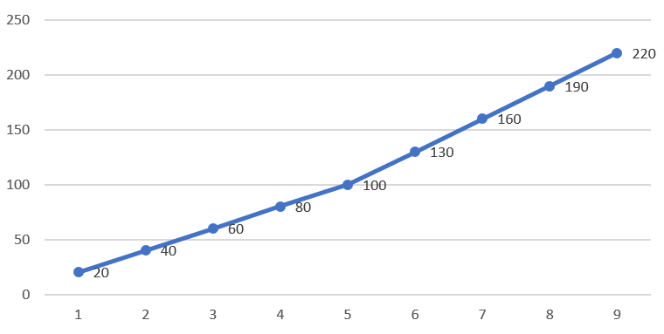
Describe a scenario that fits to the graph above. Explain.

Assessment Activities:

1. The following graph presents how a taxi company calculates the total charge per km covered.
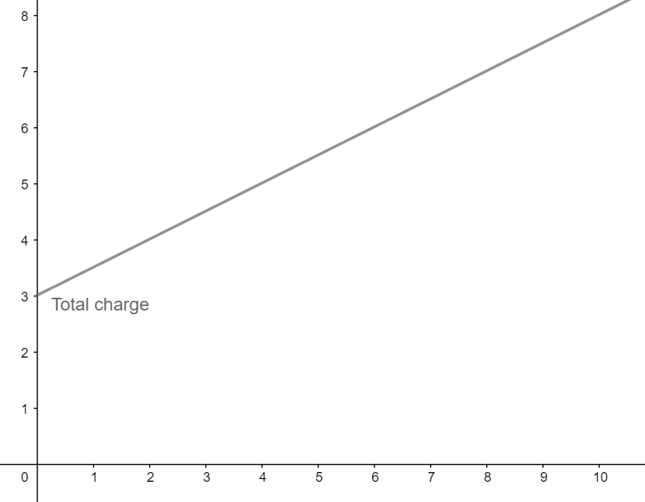
- What is the charge for a 5 km drive?
- What is the extra charge for an additional 1 km drive?
- John paid €7. How many km did he cover?
- Anna paid €3. What happened?

2. Match each description with the corresponding graph.
Description | Graph
A plumber charges with the following plan: A flat cost of €20 for a service call and an additional charge of €30 per hour.

At a gas station the price of petrol is €1,38 per litre

An offer for a birthday party charges €14 per guest. In the total cost, a discount of €40 is applied. | 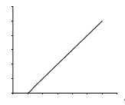

3. Study the following 3 graphs:
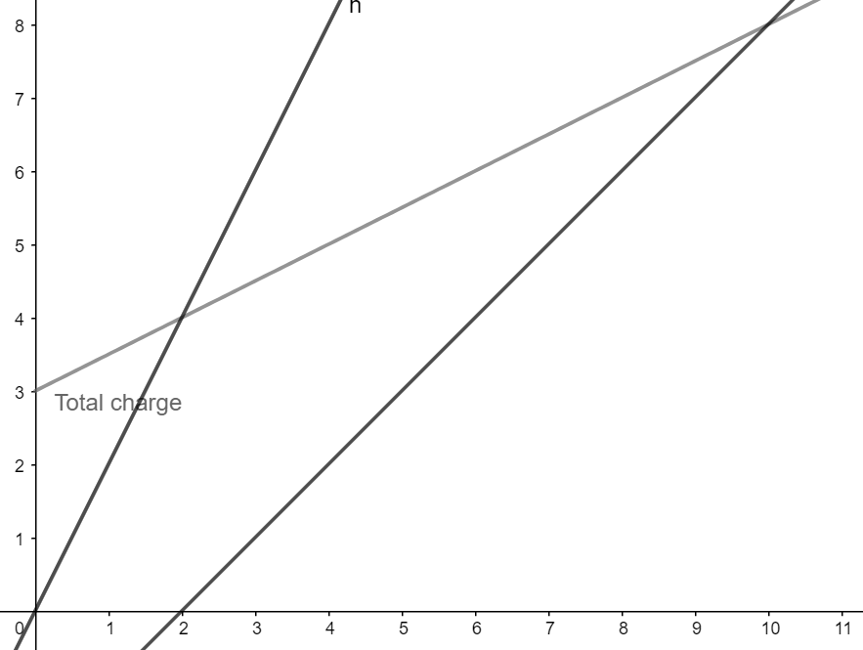
Describe a real-life scenario that corresponds to each graph.

