Module: Patterns

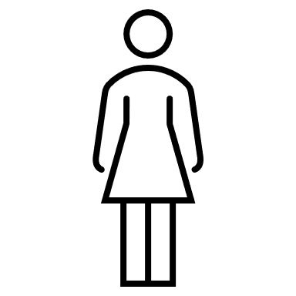
Exploration Activity 1:

Watch the video and explain how the human pyramid is created.
Video: (1017) WORLD TOP ONE TALLEST NINE LAYERED HUMAN PYRAMID PRACTICE SHOW - YouTube)

Exploration Activity 2:
Use the app “Slide and Figure” in your tablet.
Slider & Figures – GeoGebra
- How many squares are needed to construct Pyramid 12? ……………………………………………………
- How could you find the Number of Squares needed when you know the Number of the Pyramid?
….…………………………………………………………………………………………………………………………………………………………………………………………………………….

Activities:

Use the app in your tablet and describe how the pattern grows. Sums (2) – GeoGebra
………………………………………………………………………………………………………………………………………………………………………………………………………………………………………………………………………………………………………………………………………

Use the app “Squares” in your tablet. Lara creates patterns using coloured squares. Squares – GeoGebra
- Drag the slider. What is the rule of the pattern each time?
……………………………………………………………………………………………………………
- Select “Next figures” to check your answer.

(c) Select Number of grey squares = 1 and fill in the following table.
Figure Number | Figure 1 | Figure 2 | Figure 3 | Figure 4 | Figure 5 | Figure 6
Number of squares

- How many squares would Figure 13 have?
...................................................................................................................................................
(e) How could you find the Number of Squares when you know the Figure Number?
……………………………………………………………………………………………………………

- Select Number of grey squares=2. How could you find the Number of Squares when you know the Figure Number?
……………………………………………………………………………………………………………

- Select Number of grey squares=3. How could you find the Number of Squares when you know the Figure Number?
……………………………………………………………………………………………………………

Chris creates designs for textiles. Below, there are two sections from one of his designs.
1st section | 2nd section

- Describe the two sections of his design.
………………………………………………………………………………………………………………………………………………………………………………………………………………………………………………………………………………………………………………………………………

(b) Draw a section from Chris design that has three black squares.

(c) How many grey squares will be in the section with 4 black squares?
……………………………………………………………………………………………………………

(d) How many more squares does each consecutive section have?
……………………………………………………………………………………………………………

(e) Fill in the tables below.
Number of black squares | Total number of squares |  | Number of black squares | Total number of squares
5 |  |  |  | 25
8 |  |  |  | 37
14 |  |  |  | 101

(f) Chris uses the rule $2n+1$ when he knows that the number of black squares is $n$ to find the total number of squares. Explains why his rule works.
…………………………………………………………………………………………………………………..…………………………………………………………………………………………………………………………………………………………………………………………………………………

Use the app Pattern Shapes by The Math Learning Center and create your own patterns.

Figure 1 | Figure 2 | Figure 3

(a) Reconstruct the following figures on grid paper.

(b) Find the number of gray squares needed for Figure 4 and 5, without constructing them.
……………………………………………………………………………………………………………
(c) How many more gray squares are needed to construct each next figure?
……………………………………………………………………………………………………………
(d) Fill in the following table.
Figure Number | Figure 1 | Figure 2 | Figure 3 | Figure 4 | Figure 5 | Figure 6 | Figure 7 | Figure 8
Number of gray squares

(e) To construct Figure 50, you would need 204 gray squares. How many gray squares are needed to construct Figure 53?
……………………………………………………………………………………………………………
(f) Find the number of gray squares needed for Figure 20. Suggest different ways. Which is the easiest one?
……………………………………………………………………………………………………………
(g) Find the number of gray squares for Figure 100.
……………………………………………………………………………………………………………
(h) Could you construct a Figure for the pattern using 1002 squares? Explain.
……………………………………………………………………………………………………………

Extension Activities:

- Bees create honeycombs in the way shown below.
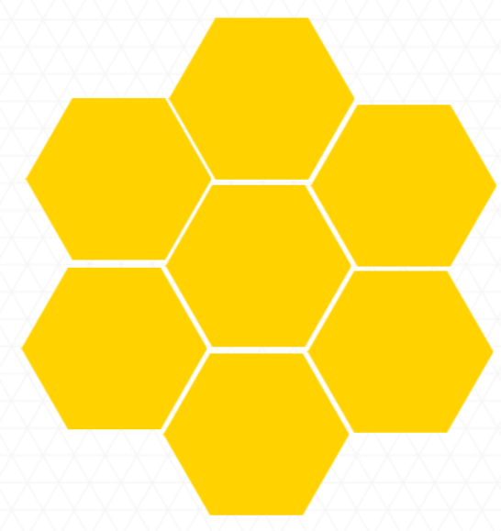 | 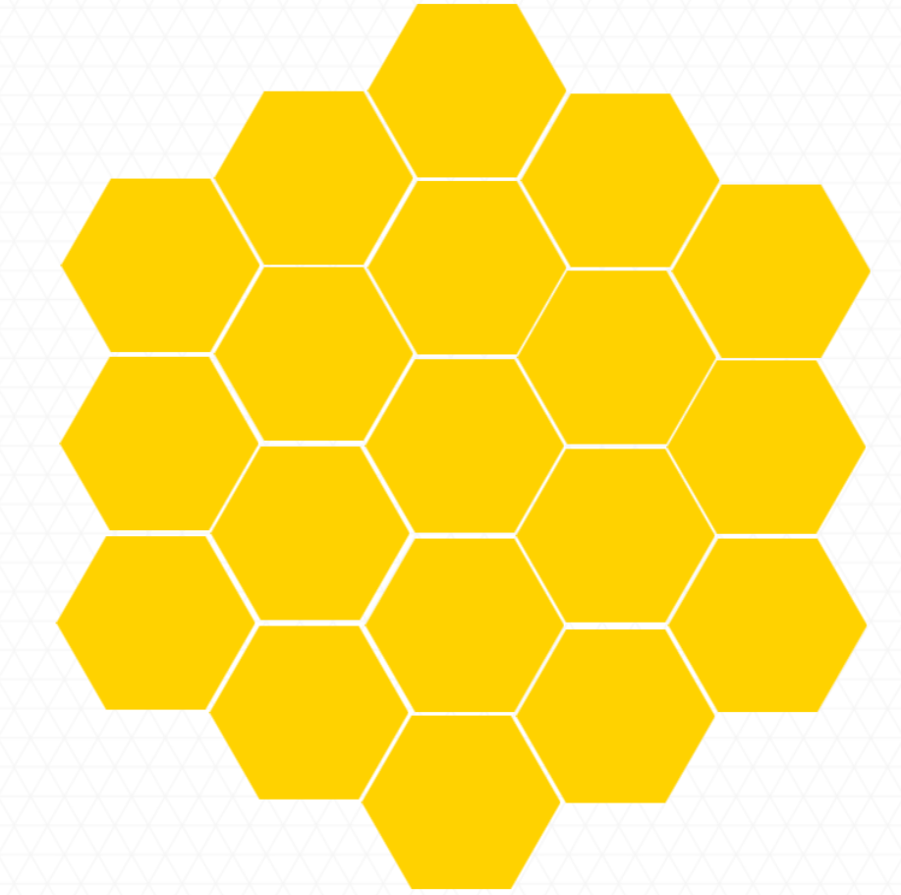
1st step | 2nd step
- Find how many hexagons will be created in the 3rd step of the honeycomb. [Use hexagon grid paper, if needed]

- Fill in the following table.

Steps | Number of hexagons
1st
2nd
3rd

- How many more hexagons would you need to create the 4th step?

- Use the app “Sums” in your tablet. Peter creates patterns using coloured squares. Sums – GeoGebra
(a) Drag the slider. What is the rule of the pattern each time?
………………………………………………………………………………………………………
- Select “Next figures” to check your answer.

- The picture below shows a sequence 1, 1, 2, 3, 5, 8, … , which is called Fibonacci sequence.
(a) Describe the rule that explains how the sequence continues.
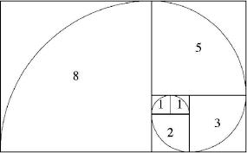

- The Fibonacci sequence appears in nature. Show and describe how the Fibonacci sequence appears in the shell below.
- Follow the instructions below to draw rectangles using the Fibonacci numbers.
    - Start by coloring one 1x1 square. Now add another 1x1 square next to it using a different color.

    - Add a 2x2 square.

    - Add a 3x3 square and continue.

- Construct the first four figures of your own growing geometric pattern.

- Construct your own growing pattern using the rule $4×\left(n+1\right)$.

- Louis has filled in the first ten numbers of the following pattern: He is adding 2 every time to find the next number.
- Describe how to find the number that corresponds to the 20th place.

- What is the rule for finding the “number” if you know the “place”?

- What would be the number for the n^{th} place?

Place | 1st | 2nd | 3rd | 4th | 5th | 6th | 7th | 8th | 9th | 10th | … | 20th | … | $n$^{th}
Number | 4 | 6 | 8 | 10 | 12 | 14 | 16 | 18 | 20 | 22

Assessment Activities:

- Select the ones that show patterns. Explain.
- 0, 2, 4, 7, 9, 11, 13, …
- 3, 6, 12, 24, 48, 96, …

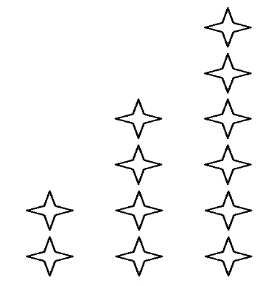

- Zoe is creating the following pattern.

- How many squares would Figure 4 have?

- How many more squares would each next figure have?
Figure 1 | Figure 2 | Figure 3

- A pattern begins with number 5 and repeatedly adds 4. What are the first five terms of this pattern?

- Follow the instructions to complete the pattern in the box below.
“Your first step is to start with number 1. Your second step is to add 3. Then, you will add 3 to each term to get to the next term”.
- Complete the following table.

Step Number | Pattern Number
1 | 1
2
3
4
5

- Create a graph (using grid paper or dynamic geometry software) based on the table above using as coordinate points the step number and the pattern number.

- Use the graph to find the pattern number for step number 12.
- Kai is constructing the following pattern.
Figure 1 | Figure 2 | Figure 3
- How many triangles would Figure 12 have?

- How many triangles would Figure $n$ have?

