Lesson Plan

Module: | Function Machines
Teaching Hours: | 3 X 40 min
Grade Level/Age Range: | Grades 5-6 (10-12 years old)
Brief Description: | The module engages students with the function machines, the graphical representation of the relationship between input and output values, and in finding the rule that correspond the input with the output values.
Design Principles: | Inquiry
 | Situatedness
 | Digital tools
 | Embodiment
- Meaningful: Build on students’ intuitive knowledge and daily life experiences with games and real-life scenarios
- Embodiment: Perceptual-motor (action-perception) experiences with noticing the correspondence between input and output values, grounding the understanding of the relation between the involved quantities with concrete actions
- Inquiry based learning: explore qualitative and quantitative relations (additive, multiplicative, linear)
- Digital: tablet devices equipped with appropriate apps
- Didactical phenomenology / situatedness: the correspondence of values from data sets (input-output) is recorded, tabularized and mathematized
Functional Thinking: | Input – Output
 | Covariation
 | Correspondence
 | Object
Learning Goals: | - Conceptualize arithmetic operations as functions in an implicit way  - Conceptualize functions as an input-output process  - Notice, generalize and express additive, multiplicative and linear relations  - Use functional expressions to model real-life scenarios

Activities

Exploration
Guess my Birthday
Students follow the set of instructions below using their birthday. They find a number, which represents the date and the month of their birthday. After that the teacher figures out the date of birth of each student based on the output value of his/her calculations (subtract 5 from the last two digits of the outcome to find the date and subtract 2 from the other two digits to find the month).
For example: If a student says that the result is 1230, then the student was born on the 25th of October (30-5=25 and 12-2=10).
Instructions:
Make the following calculations.
- Write down the number that corresponds to your month of birth
- Multiply by 5
- Add 7
- Multiply by 4
- Add 13
- Multiply by 5
- Add the number that corresponds to your day of birth
- What is your result?

Suggested tools/materials/: Students Handout
Estimated duration: 15 minutes

Investigation
The teacher marks four spots in the classroom (the blue, the red, the yellow and the green) and acts as the function machine. Each student approaches the teacher, who asks three to four questions privately. One of the questions is how many brothers/sisters you’ve got. Based on the answer to this question, he/she sends the student to the appropriate spot (blue: no brothers/sisters, red: 1, yellow: 2, green: three or more). The students do not know the rule and they are asked to figure out why they were sent to the same spot.
In the whole-class discussion students present their ideas. The teacher intuitively emerges fundamental ideas of the function concept: Each student could be sent only to one color spot, based on the rule of the machine (teacher), and a number of students could be sent to the color spot.
Next, the students suggest their own machines, explain the rule and the possible values of the two sets.
Suggested tools/materials: Coloured papers
Estimated duration: 20 minutes

Activity 1.
Students work in pairs on a GeoGebra app (Function Machine (1) – GeoGebra) on their tablet devices, as shown below.
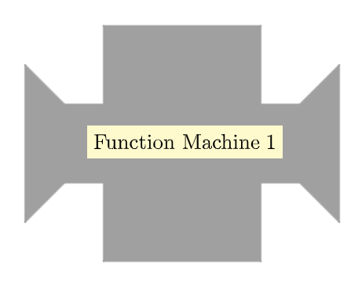
- Students choose function machine 1 (additive structure) and explore how it works when they insert into the machine different values. Then, they are asked to fill in the following table and explain the rule.
Input | Output
0
3
5
7
10
12
15

- Afterwards, students choose function machine 3 (multiplicative structure) and explore how it works when they insert into the machine different values. The teacher initiates a discussion in whole class to find out which machine creates additive rules and which one creates multiplicative ones.
Suggested tools/materials: Tablet devices, App, Students Handout
Estimated duration: 10 minutes

Activity 2.
Students continue working in pairs on the GeoGebra app (Function Machines (11) – GeoGebra) on their tablet devices. In this task, students are asked to program a function machine by selecting one of the four operations.
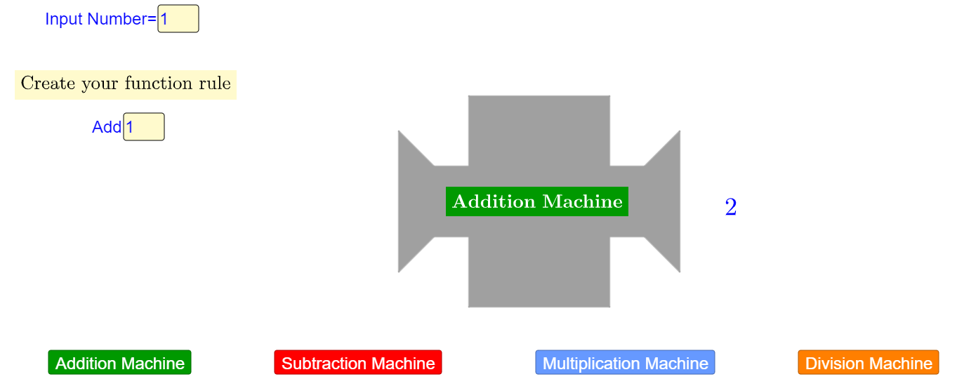

At first, they program two function machines that create the following tables:
Input | Output
1 | 7
2 | 14
4 | 28
7 | 49
Input | Output
6 | 2
7 | 3
8 | 4
10 | 6

Then, they asked to program their own machine and fill in a table of values. Each student shows the filled table to one of their classmates and asks him to program a function machine that gives that table.
Input | Output

Suggested tools/materials: Tablet devices, App, Students Handout
Estimated duration: 15 minutes

Activity 3.
Students combine functions machines, machines 5a and 5b (Function Machines (5) – GeoGebra), as shown in the following figure.
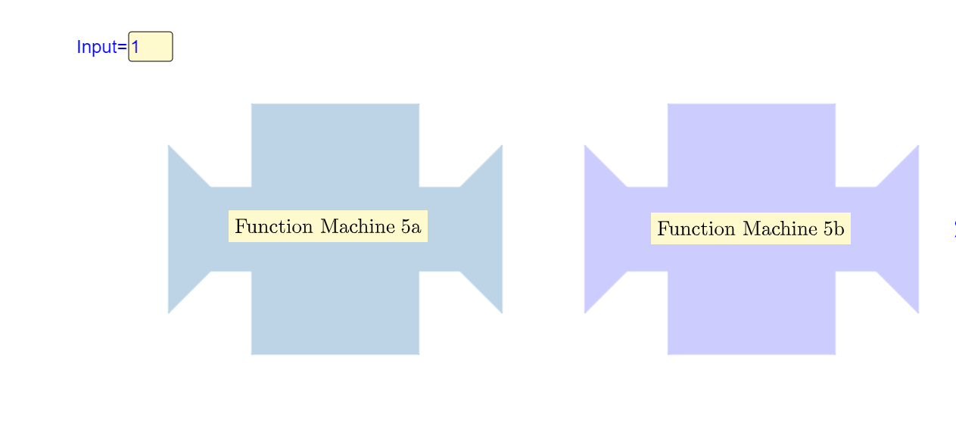
Students fill in the table and explain to the whole class how the output value is calculated.
Input | Output 1 | Output 2
1
3
5
10
12

Then, they use machines 6a and 6b (Function Machines (6) – GeoGebra) and complete the new table.
Input | Output 1 | Output 2
1
3
5
10
12
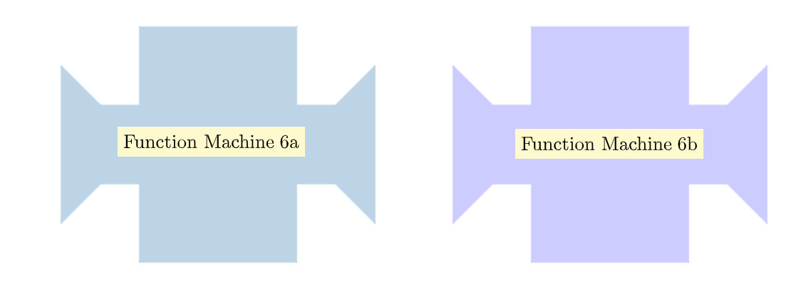

The teacher asks them to compare the two tables and explain how the change in the order of the machines modifies the output values of the table, using examples from their work.
Students work independently for Question (d)-(e) and then share their ideas with their classmates.
Suggested tools/materials: Tablet devices, App, Students Handout
Estimated duration: 15 minutes

Activities for Practice:
Activity 4:
Students create a combination of two function machines that give the following tables:
Input | Output
1 | 3
2 | 5
3 | 7
4 | 9
Input | Output
1 | 0
2 | 3
3 | 6
4 | 9

The teacher asks them to explain their work and to describe the rules of each table.

Activity 5:
Students create a combination of function machines (at least two) that give the following result: “The input value is the same with the output value”.
(This task could be adjusted for other machine combinations, if further practice is needed)
Suggested tools/materials: Tablet devices, App, Grid paper, Cubes
Estimated duration: 10 minutes

Extension Activities:
This section presents questions of different difficulty level.
In Activity 6, students engage again in programming a machine using the rule “add 4” and a second one with the rule “multiply by 5”. Students fill in tables with input values. They also asked to use as input values, numbers 0 and 1. Then, they explain how the output value changes when the input value increases by 1. Students insert in both machines the values 30, 31, 32 and 33 and then 50, 51, 52 and 53 to compare the unit change in the two machines.
In Activity 7, students engage with a mathematical problem “Company A rents a bicycle based on the following: €8 for each hour and additional €5 for insurance.” Students create a combination of machines that shows the cost of renting a bicycle per hour and explain how they worked. Also, they describe the graph and answer questions. Furthermore, create a combination of machines to represent Company B (Company B is cheaper than Company A for renting a bicycle for less than 4 hour) and explain their answer based on the provided graphs.

Suggested tools/materials: Students Handout

Estimated duration: 30 minutes

Assessment

- In the following machine, words are entered and the machine gives as an output the number of letters of the word (see example).

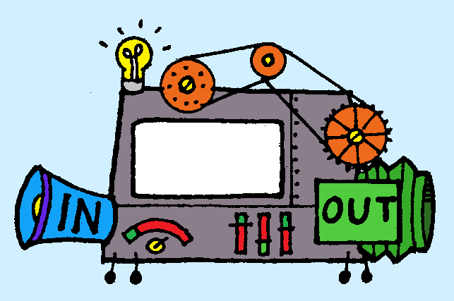
MATHEMATICS

11

- Find the output values for the following input:
  - GEOMETRY
  - ALGEBRA
  - FUNCTION
  - NUMBERS

- Suggest possible input values for the following output values:
  - 8
  - 9
  - 10

- Find below the rules of 5 Function machines.

MACHINE A: Add 5
MACHINE B: Subtract 2
MACHINE C: Multiply by 3
MACHINE D: Divide by 2

Provide a combination of machines that could give the following tables. Explain the order.

TABLE 1 TABLE 2

Input | Output
1 | 4
2 | 5
4 | 7
7 | 10
Input | Output
1 | 8
2 | 11
5 | 20
10 | 35

TABLE 3 TABLE 4

Input | Output
1 | 3
3 | 4
7 | 6
15 | 10
Input | Output
5 | 9
7 | 15
10 | 24
11 | 27

Digital Tools:
Activity 1 – Part A:
https://www.geogebra.org/m/c5ntdqmw
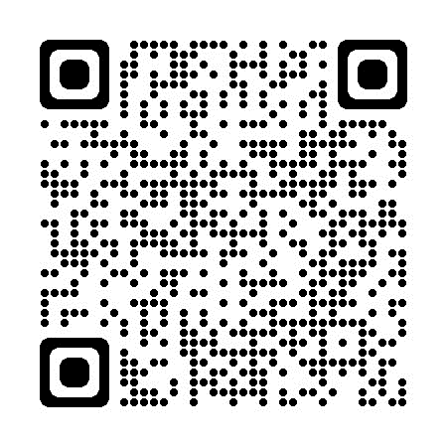
Activity 1 – Part B:
https://www.geogebra.org/m/scw7vxrx
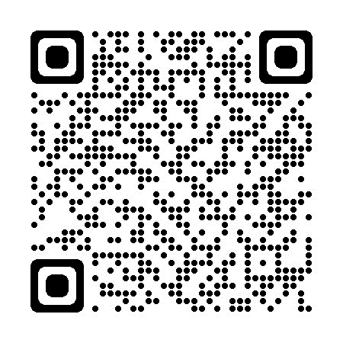
Activity 2:
https://www.geogebra.org/m/evfnv3v3
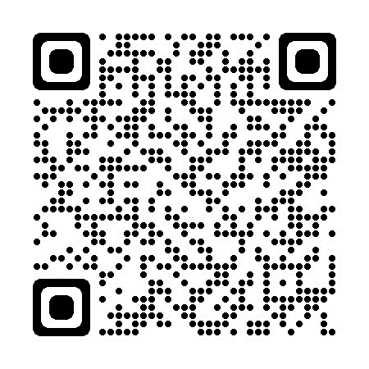
Activity 3:
https://www.geogebra.org/m/pkhcktyz
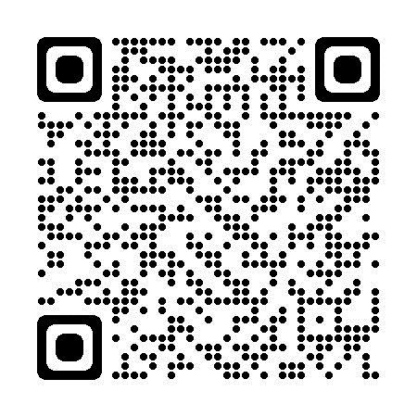
https://www.geogebra.org/m/bgznfuhn
