Module: Function Machines

Exploration
“Guess my Birthday”
Make the following calculations:
- Write down the number that corresponds to your month of birth
- Multiply by 5
- Add 7
- Multiply by 4
- Add 13
- Multiply by 5
- Add the number that corresponds to your day of birth
- What is your result?

Activities
Activity 1 (Function Machines – GeoGebra):
PART A
Choose function machine 1 (Function Machine (1) – GeoGebra). Explore how it works by inserting different values.
- Fill in the following table.
Input | Output
0
3
5
7
10
12
15

- What is the output value when the following numbers are entered?

$50→$ $70→$ 100$→$

- Explain the machine rule.

PART B
Choose function machine 3 (Function Machine (3) – GeoGebra). Explore how it works by inserting different values.
- Fill in the following table.
Input | Output
0
3
5
7
10
12
15

- What is the output value when the following numbers are entered?

$50→$ $70→$ 100$→$

- Explain the machine rule.

Activity 2:
The following figure shows the programming section of the applet. You can create your function rule, by choosing one of the four operations (Function Machines (11) – GeoGebra).
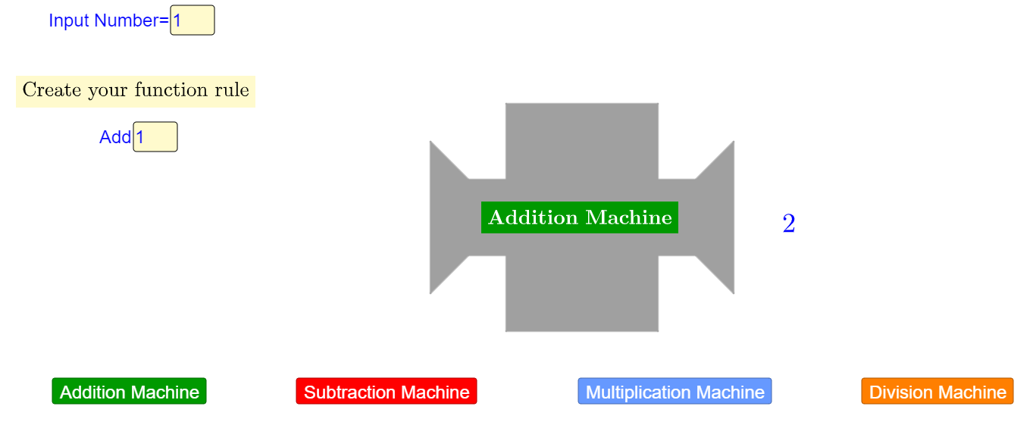

- Program two function-machines that create the following tables.

Input | Output
1 | 7
2 | 14
4 | 28
7 | 49
Input | Output
6 | 2
7 | 3
8 | 4
10 | 6

- Program you own machine and then fill in a table of values. Show it to one of your classmates and ask him/her to program a function machine that gives this table.
Input | Output

Activity 3:
You can combine functions machines. Choose machines 5a and 5b (Function Machines (5) – GeoGebra) and explore what happens.
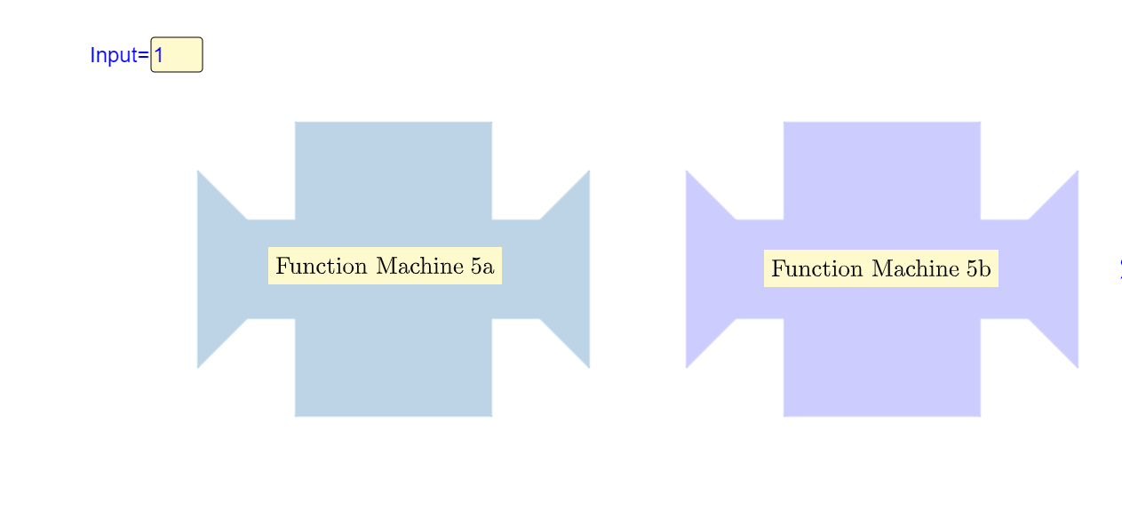

(a) Fill in the following table. Explain how the output value is calculated.
Input | Output 1 | Output 2
1
3
5
10
12

- Now, choose machines 6a and 6b (Function Machines (6) – GeoGebra) and complete the new table.

Input | Output 1 | Output 2
1
3
5
10
12
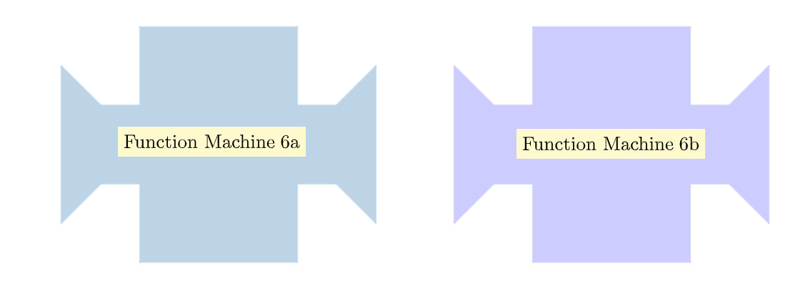

- Compare the two tables. Explain how the change in the order of the machines modifies the output values of the table. Show using examples.

- What is the output value when the following numbers are entered in each combination?

Combination 1

$50→$ $70→$ 100$→$

Combination 2

$50→$ $70→$ 100$→$

- Find the input values the give the following output values

Combination 1

$___→8,5$ ___ $→$ 13

Combination 2

$___→$5,5 $___→14$

Activities for Practice:
Activity 4
Create a combination of two function machines that give the following tables. Explain your work. Describe the rules of each combination of machines.

Input | Output
1 | 3
2 | 5
3 | 7
4 | 9
Input | Output
1 | 0
2 | 3
3 | 6
4 | 9

Activity 5
Provide a combination of function machines (at least two) that give the following results:
“The input value is the same as the output value”.

Extension Activities:
Activity 6
Program a machine using the rule “add 4” and a second one using the rule “multiply by 5”.
- Fill in the following tables with your own input values.
Rule “add 4” Rule “multiply by 5”
Input | Output
Input | Output

- Insert in both machines the value 0 and then value 1. How does the output value change when the input value increases by 1?

- Insert in both machines the values 30, 31, 32 and 33 and then 50, 51, 52 and 53. How does the output value change when the input value increases by 1? Explain and compare the unit change in the two machines.

Activity 7
Company A rents a bicycle based on the following: €8 for each hour and an additional €5 for insurance.
- Create a combination of machines that gives the cost of renting a bicycle, in respect of the hours of renting. Explain.

- Describe the graph created at the graph window.

- Use the graph to answer the following question: Helen does not want to spend more than 100 euro. What is the maximum number of hours that she could afford to rent a bicycle?

- Company B is cheaper than Company A for renting a bicycle for less than 4 hours. Create a combination of machines that gives the cost or renting a bicycle for Company B. Explain your answer based on the provided graphs.

Assessment Activities:
- In the following machine, words are entered and the machine gives as an output the number of letters of the word (see example)

MATHEMATICS

11

- Find the output values for the following input:
  - GEOMETRY
  - ALGEBRA
  - FUNCTION
  - NUMBERS

- Suggest possible input values for the following output values:
  - 8
  - 9
  - 10

- Find below the rules of 5 function machines.

MACHINE A: Add 5
MACHINE B: Subtract 2
MACHINE C: Multiply by 3
MACHINE D: Divide by 2

Provide a combination of machines that could give the following tables. Explain the order.

TABLE 1 TABLE 2

Input | Output
1 | 4
2 | 5
4 | 7
7 | 10
Input | Output
1 | 8
2 | 11
5 | 20
10 | 35

TABLE 3 TABLE 4

Input | Output
1 | 3
3 | 4
7 | 6
15 | 10
Input | Output
5 | 9
7 | 15
10 | 24
11 | 27

