Lesson Plan

Module: | Distance-Time
Teaching Hours: | 5 x 40-minutes
Grade Level/Age Range: | 5th-6th grade (10 – 12 years old)
Brief Description: | The module engages students with the relationship between distance and time, the exploration of the graphical representation as well as the rate of change in distance/time scenarios.
Design Principles: | Inquiry
 | Situatedness
 | Digital tools
 | Embodiment
- Meaningful: Build on students’ intuitive knowledge and daily life experiences with real-life scenarios
- Embodiment: Perceptual-motor (action-perception) experiences with noticing the correspondence relation between distance and time
- Inquiry based learning: explore the relation between distance and time
- Digital: tablet devices equipped with appropriate apps
- Didactical phenomenology / situatedness: the covariation and correspondence relations are recorded, tabularized, described and mathematized
Functional Thinking: | Input – Output
 | Covariation
 | Correspondence
 | Object
Learning Goals: | - Conceptualize the rate of change in terms of distance-time  - Conceptualize intuitively the formal definition of function in the context of distance-time scenarios  - Interpret the graphical representation of distance-time scenarios  - Identify the relationship between distance-time and express it (verbally/symbolically) – Find distance for given time and vice-versa  - Create graphs of distance-time  - Compare graphs of distance-time

Activities

Explorations

Exploration 1: Find the rule by playing outside
Outside the classroom, the teacher places a number line from 0 to 100 (as shown in the picture below) on the floor. Students work in pairs (Student A and Student B). Each student picks a card. The cards show either a graph or a set of instructions. For example, the instructions could be ‘move 5 steps forward (1 step per second) starting from 0, stop for 2 seconds and then move 3 further steps forward’. Student A counts the time (in seconds) and Student B performs the route. The rest of the students check that the pair represents the graph/set of instructions correctly.
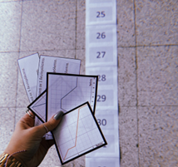

Exploration 2.
Students work in pairs on a Desmos app on their tablet devices, as shown below.
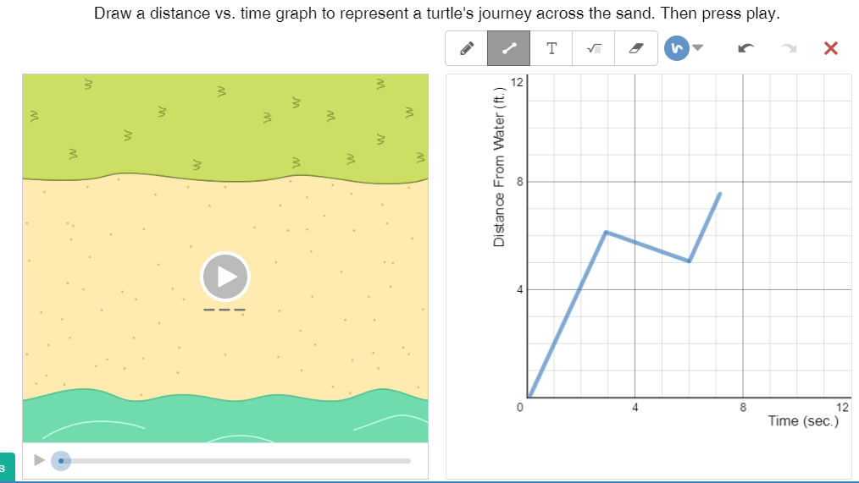
Students are asked to draw points and various sketches on the graph. Then, they are asked to describe how the turtle moves by playing the video.
The teacher could guide the explorative work using the following guidelines:
- Draw points and describe the place of the turtle.
- Draw different sketches and describe how the turtle moves.
- Draw a line sketch and observe the turtle’s journey. Draw a steeper line. How does the turtle’s journey changes?
- Draw line sketches that start from different points on the y-axis and observe the turtle’s journey. How does the turtle’s journey change?
Useful questions: What quantities are shown in the two axes? How does the turtle journey changes?
Suggested tools/materials: Tablet devices, App
Estimated duration: 15 minutes

Exploration 3.
The class works with the motion sensor technology in groups. The teacher gives cards to each group that describe a situation. The group enacts the situation using the machine and then describes how the produced graphs correspond to the enacted situation. Then, they are asked to create their own cards and exchange them between groups.
Suggested tools/materials: Motion sensor technology
Estimated duration: 30 minutes

Activities

Students continue working in pairs with the Desmos app on the tablet, as shown below. Students are asked to make a hypothesis about the journey of the turtle based on the graph.
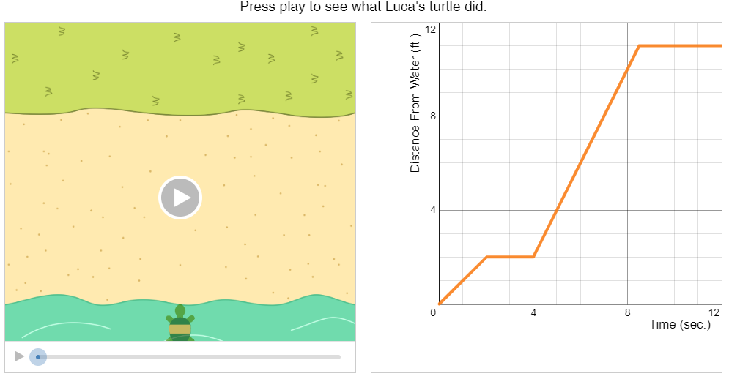
Then, they are asked to play the video and explain how the journey of the turtle is shown on the graph. Students are asked questions to correspond the time with distance based on the data provided on the graph. They are also asked to compare the different segments of the graph (e.g. 0-2 seconds and 4-8.5 seconds). For example:
- Describe the journey of the turtle for 0-2 seconds, 2-4 seconds, 4-8.5 seconds and 8.5-12 seconds.
- What is the turtle’s distance from the water at 2 seconds? At 4 seconds? At 6 seconds?
- When is the turtle’s distance from the water 6 feet? 8 feet? 10 feet?
Suggested tools/materials: Tablet devices, App
Estimated duration: 15 minutes

Students work independently. They read the four scenarios and sketch the respective graph (in the two out of the four scenarios there are no quantitative data). Students also describe the journey of the turtle for two given graphs. Finally, students check their answers using the Desmos app and discuss in whole class how they have worked. Below, there are indicative answers to the task:
1
2
3
4
5 | The turtle more away from the water 6 ft in 3 seconds. Then, the turtle stays there for 2 seconds. The turtle returns to the water by walking 3 ft in 3 seconds and stays there for 2 more seconds.
6 | The turtle walks away from the water by walking 2 ft in 2 seconds. The turtle stays there for 2 seconds. Then, the turtle continues walking away from the water covering 9 ft in 4,5 seconds and stays there.

Suggested tools/materials: Handouts, Tablet devices, App
Estimated duration: 30 minutes

Activity 3
The students compare the distance from the starting point over time for the two girls. They are asked to find at what distance the two girls are found after one hour, in order to reach the general rule between distance and time.
Suggestions for questions: At what distance from the starting point are each girl after 2 hours? How much time did each girl need to walk 9km? How much distance each girl walks per hour?
Suggested tools/materials: Handout
Estimated duration: 15 minutes

Activity 4
The students sketch the graph that corresponds to each scenario. The axes have been named and students need to add the measurement units.
Suggested tools/materials: Handout
Estimated duration: 10 minutes

Activity for Practice
In this activity, students explain how the two routes differ. They respond to questions regarding the distance from the starting time over time and generalize the relation of distance-time.
Suggested tools/materials: Handout
Estimated duration: 20 minutes

Extension Activities
In Activity 1, students sketch graphs that correspond to the given scenarios by naming the two axes. In Activity 2, students write a scenario that describes their journey from their house to the school and then sketch the respective graph by naming the two axes.
Suggested tools/materials: Handout, Grid paper or software
Estimated duration: 30 minutes

Assessment Activities

- Use the data in the following table to sketch a graph (on a grid or a software application) to show Anna’s walking journey from her house to the gym.

Distance (metres) | Time (minutes)
500 | 5
1000 | 10
1500 | 15
2000 | 20

- (a) John runs 8 km per hour at a constant speed. How many kilometers will he run in three hours?

(b) Express the relationship between distance and time.

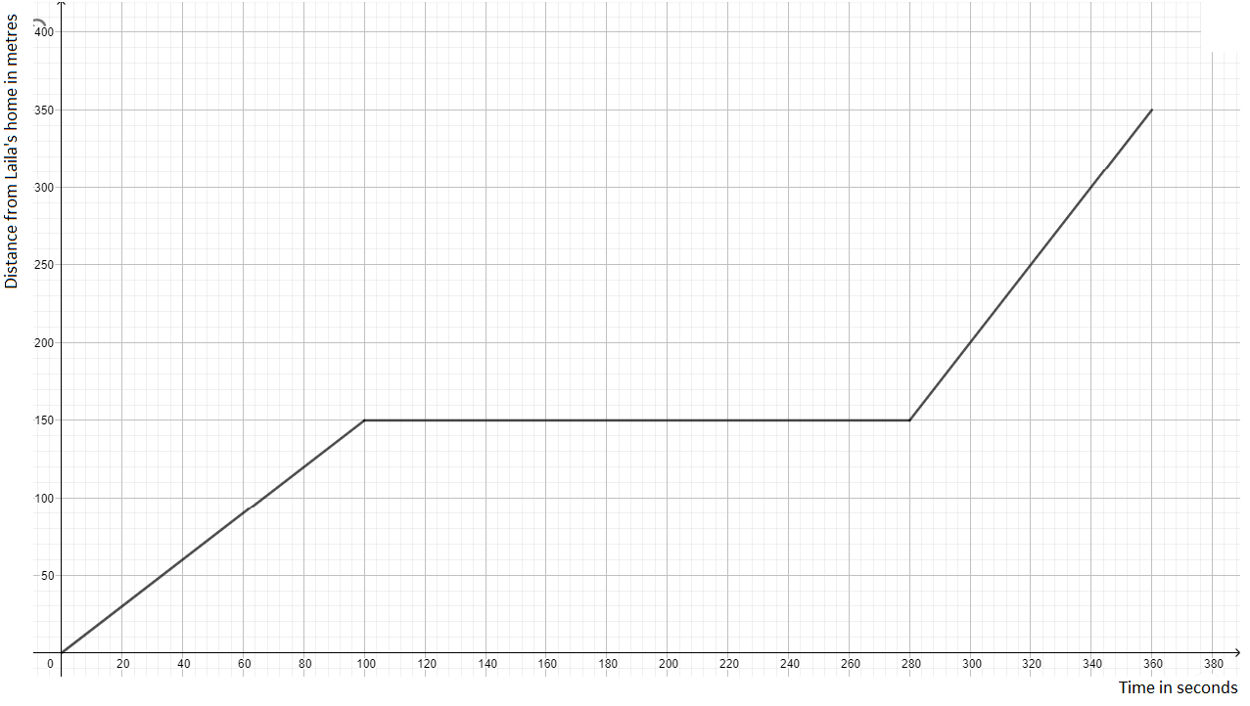
- Laila walks from her home to her grandmother’s house in a linear path, a distance of 350 meters. Describe her journey for each of the following graphs.

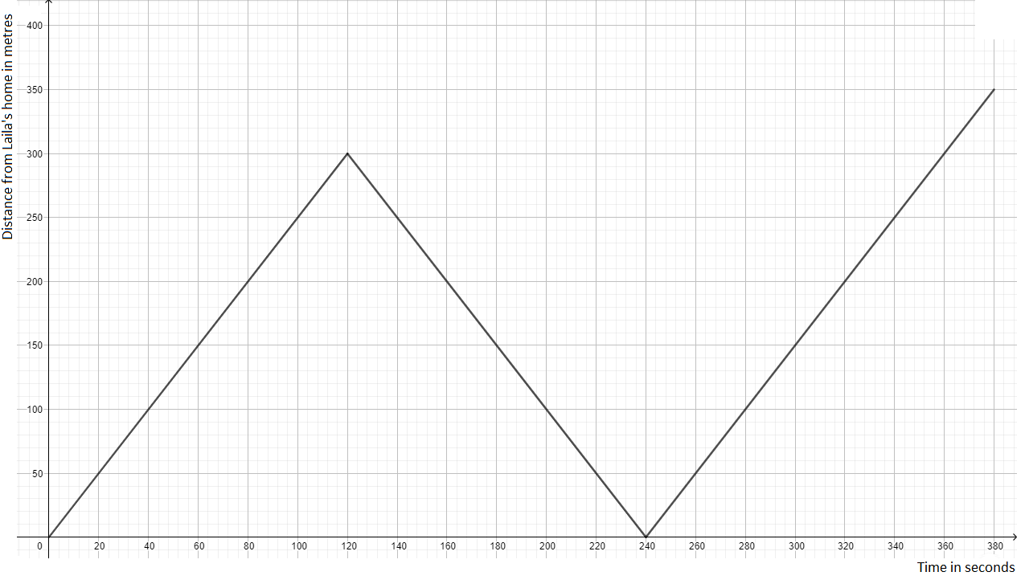

Digital Tools:
Exploration 2:
https://teacher.desmos.com/activitybuilder/custom/5ddbf9ae009cd90bcdeaadd7?collections=featured-collections,5da6476150c0c36a0caf8ffb
Exploration 3:
https://tim-lutz.de/funktionenlaufen/indexSelbstZeichnen.html
Activity 1 and 2:
https://teacher.desmos.com/activitybuilder/custom/5ddbf9ae009cd90bcdeaadd7?collections=featured-collections,5da6476150c0c36a0caf8ffb

