**Walking Graphs digitally**

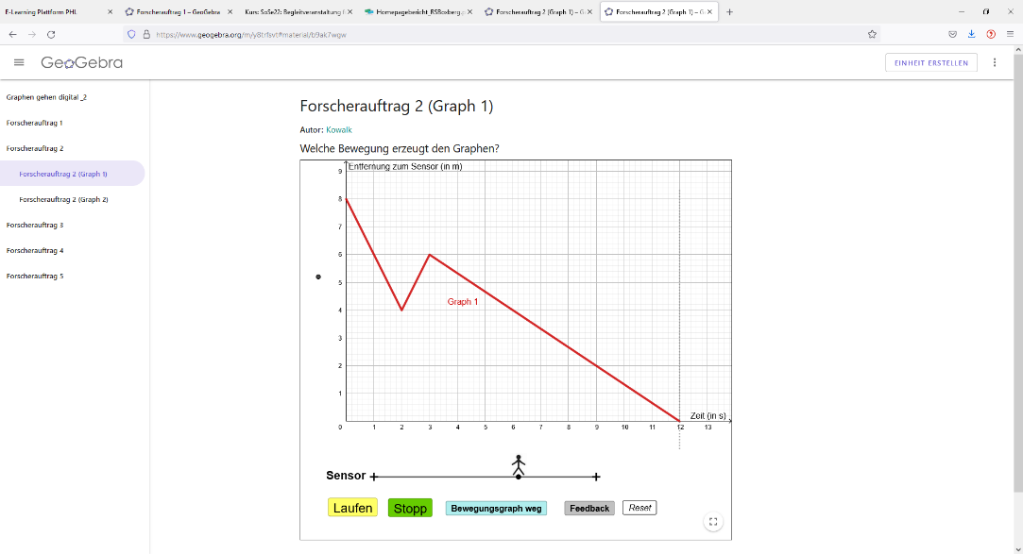Imagine, you are moving in front of an ultrasonic sensor (sensor) that measures distance as a function of time. Your movement is represented as a graph in the coordinate system.



reality: walking in front of a sensor digitally: walking graphs in GeoGebra

Today, you will discover how to create different graphs using the movements of your body. You will learn how graphs and movements are related and how to describe the relationship.

Scan the QR-code and open the applet *Walking graphs digitally*:

Complete the research assignments in order and record your results.

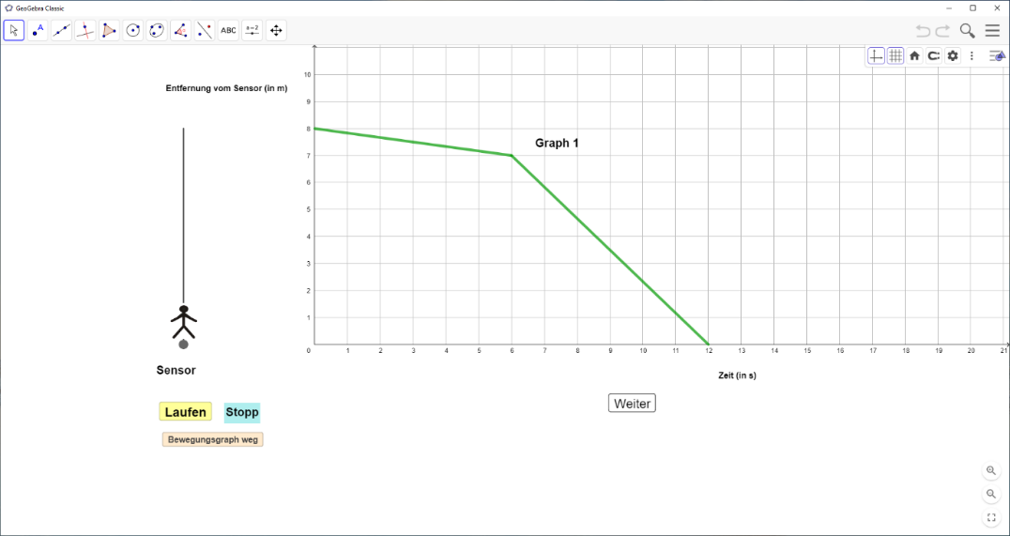

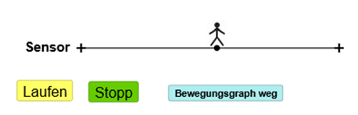Short explanation: This is you: . You can change the position of the point in the graph by moving the figure on the line with your finger. By pushing the yellow button (walk/stop), you activate or stop the recording of the graph of your movement.

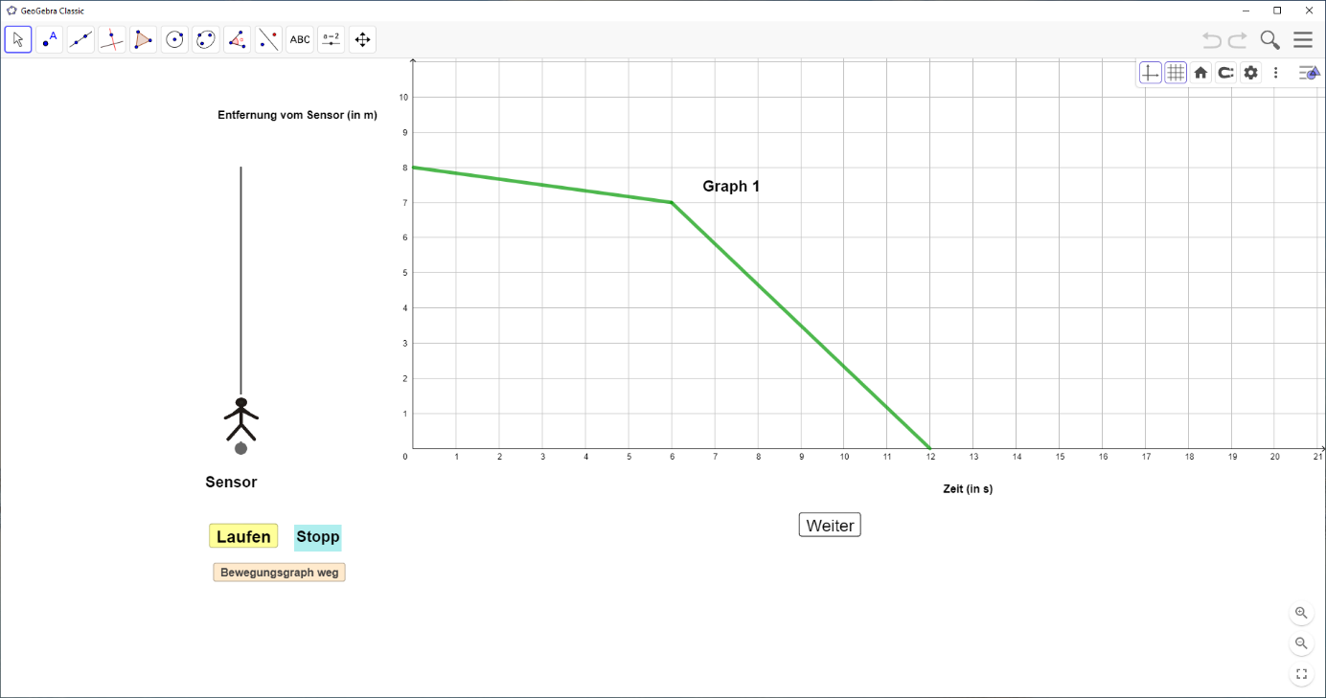**Research assignment 1:** What graph is created by different movements?

1. Open research assignment 1 in GeoGebra. Touch the point and complete the movement described on the cards below. Afterwards, sketch the created graph in the second column.
2. Find and record the corresponding description of each graph in the right column: *“the graph increases steadily”; “the graph decreases steadily”; “the graph first increases slowly, then faster and faster”; “the graph increases and decreases”; the graph is parallel to the time axis”.*

|  |  |  |
| --- | --- | --- |
| **Movement** | 1. **Graph** | 1. **Description of the graph** |
|  |  |  |
| ① I start far away from the sensor. I move **slowly and evenly** towards the sensor. | distance sensor  time  Distance sensor  time |  |
|  |  |  |
| ② I start in front of the sensor. I move **slowly and evenly** away from the sensor. |  |  |
|  |  |  |
| ③ I start in front of the sensor. I move away from the sensor getting **faster and faster.** | Distance sensor  time |  |

|  |  |  |
| --- | --- | --- |
| **Movement** | **Graph** | **Description oft he graph** |
|  |  |  |
|  |  | *The graph runs on the x-axis. After 5 seconds, the graph increases steadily and fast.* |
|  |  |  |
|  | Distance sensor  time  5 |  |

1. Fill in the empty cells.

Distance sensor

time

**Research assignment 2:** Which movement creates the graph?

1. Open research assignment 2 (graph 1) in GeoGebra. Walk the given graph and pay attention to your movement. Describe your movement in 4 sentences.

**Graph 1**

|  |  |
| --- | --- |
| ① |  |
| ② |  |
| *③* |  |
| ④ |  |

1. Open research assignment 2 (graph 2). Complete the same task as for graph 1.

**Graph 2**

|  |  |
| --- | --- |
| ① |  |
| ② |  |
| *③* |  |
| ④ |  |

**Research assignment 3:** What does the graph look like?

1. Open research assignment 3 (graph 1) in GeoGebra. Watch the person’s movement. What graph is created by the movement? First, draw the graph in red, then check your solution.

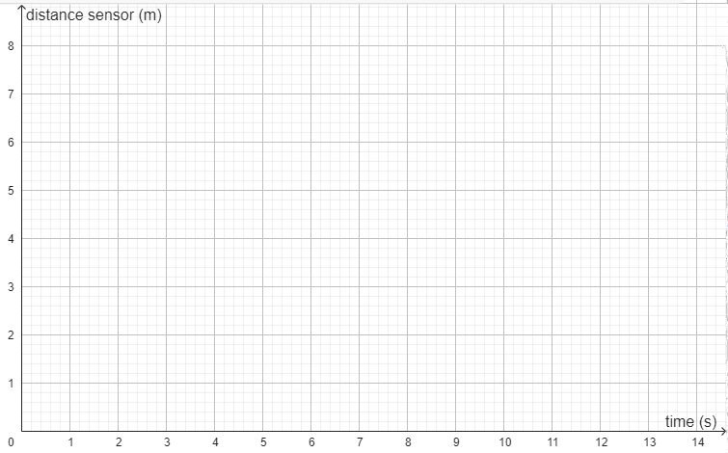

1. Open research assignment 3 (graph 2) in GeoGebra. Complete the same task as for part a). Draw the graph in blue.
2. Fill the empty spaces with help of the following terms*: flatter, steeper, increases, parallel, vertical, decreases.* (Two terms remain unused.)

① The faster you move, the _______________________ is the graph.

② The graph is ____________________ to the x-axis when you stop.

③ If you move away from the sensor, the graph _______________.

④ If you move toward the sensor, the graph ________________.

1. Can you explain statement ①? Why is this the case?

**Research assignment 4:** Which graphs can't be walked? (without GeoGebra)

1. Draw as many graphs as possible that you can’t walked.

Distance sensor

time

1. Provide reason why these graphs can’t be walked.