Activity 2
Estimate which vessel contains the most water. Draw the vessel you have chosen.

Activity 4
Each student will be assigned two images of graphs depicting the dependence of the height of the water level (y-axis) on the volume of water poured into the vessel (x-axis). Sketch what a vessel corresponding to your graphs might look like.

Activity 5
Students will stand at the station indicated by the letters on their graphs.
Those at the station will compare their drawings of the vessels. What did you find?

Activity 6
Sketch the vessels according to the agreement made at the stations.

Activity 7
We poured the same volume of water into two vessels - blue and green (see images).
The images contain graphs drawn by the students, describing the dependence of the height of the water in the vessel on the volume of water poured into the vessel. Which student is correct, and why?
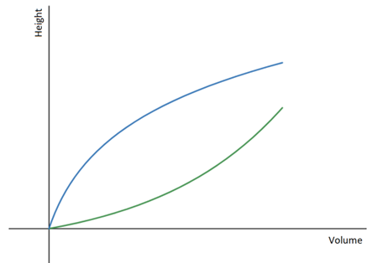 | 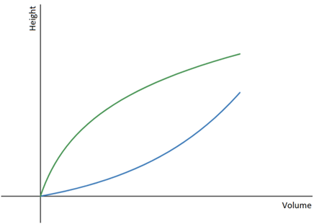
Ann: As I show in the graph, the green vessel widens at the top, and the blue vessel tapers upward, and yet, there is the same volume of water in both vessels. | Brian: I think the opposite is true. The green vessel widens at the top, so the line doesn't go up as fast in comparison to the blue vessel, which increases more quickly as water is added.
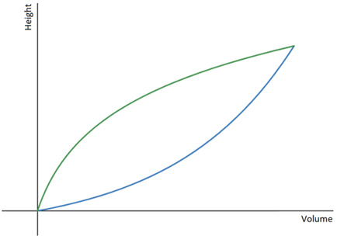 | 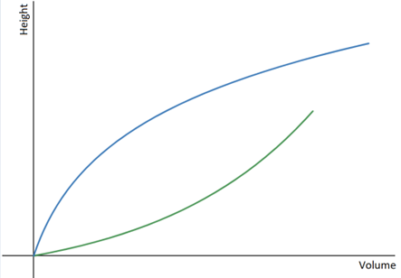
Emma: I think Brian is right, but the lines should end at one point, because we have just as much water in both vessels. | Philip: I agree with Ann, but we don't know at what points the lines on the graph stop.

