Lesson plan

Module: | Various vessels
Number of hours: | 1 - 2 lessons
Grade level: | 9th year of primary school
Short Description: | In this lesson we will look at the relationship between the volume of water poured into a vessel, and the height of the water in the vessel (the covariance aspect of the concept of function - the dependence of the height of the water in the vessel on the volume of water poured into the vessel). We will describe this relationship for vessels of different shapes. We will use different representations of the concept of function (graph, table, verbal description). Students should realize that the shape of the vessel affects the relationship between the variables they are investigating, and that each representation they create illustrates this functional relationship and provides a different perspective on it.
Principles of creation: | Research
 | Situational thinking
 | Digital tools
 | Embodiment
Functional thinking: | Input - Output
 | Covariation
 | Correspondence
 | Object
Objectives: | - Know how to fill in values in a table and mark them on a graph.  - Recognise that the shape of the vessel affects the relationship between the variables under investigation and be able to explain how it does so.  - Recognize that a function can increase (and decrease) in different ways, not just linearly.  - Link different representations of the concept of function (table, graph, rule, and verbal description).  - Become aware of the connection of functional relationships and their different representations in actual situations.

Activities

Lesson 1
The introduction of the lesson builds on the activities in the previous lesson (Change Is Change). If the teacher has not implemented these activities, it is necessary to allow more time for Activity 1 implemented in the GeoGebra.
The teacher will run the GeoGebra activity at https://www.geogebra.org/m/qynfuvn5 with the class. It is necessary to click on the "Create Class" option on the top right. The teacher must have created an account on geogebra.org

Engage

Activity 1
Today we will be tracing the curves. Click "+". Then move it around to trace the curve as accurately as possible.
How would you describe your movement when you are successful in tracing a curve?
Assign descriptions to each curve:
1. Increasing with a constant rate of change
2. Constant
3. Decreasing with a constant rate of change
4. Decreasing with a decreasing rate of change
5. Increasing with a decreasing rate of change
6. Decreasing with an increasing rate of change
7. Increasing with an increasing rate of change
- At the beginning of the activity, divide the students into groups. Each group should consist of three or four students.
- In each group the students carry out the activity on the tablet and agree on the assignment of descriptions to each curve.
- The aim of the activity is to agree on a verbal description of the graphs.
Suggested aids, tools:
- Tablets
Estimated time: 10 minutes (including dividing students into groups)
- In the context of a discussion of an increasing function with an increasing rate of change, and an increasing function with a decreasing rate of change, the teacher can bring up a true-to-life event, for example, the COVID 19 pandemic.
- Before the next activity, the teacher will fill the prepared vessels to about half their height with water.

Activity 2
Estimate which vessel contains the most water. Draw the vessel you have chosen.
Suggested aids, tools:
- A variety of vessels into which the water will be poured
Estimated time: 5 minutes
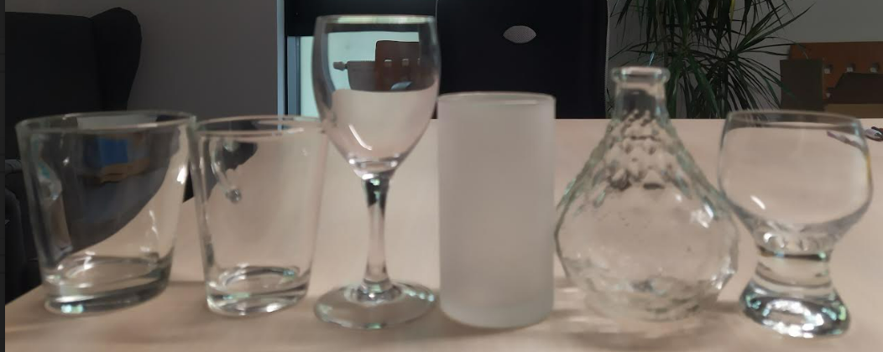
Sample vessels

Explore/Explain

Activity 3
You will work with different vessels. You will gradually pour water into these vessels (the amount of water added depends on the position and the shape of the vessel). On the prepared worksheet:

1. Sketch the vessel.
2. Predict what a graph will look like that shows the dependence of the height of the water (measured from the student’s desk) on the volume of the water poured into the vessel.
3. Record the height of the water in the table for each trial adding 50 or 30 ml of water into the vessel.
4. Record the data from the table in a graph.
5. Describe the resulting graph and compare its differences to the graph you sketched before you started the measurement.

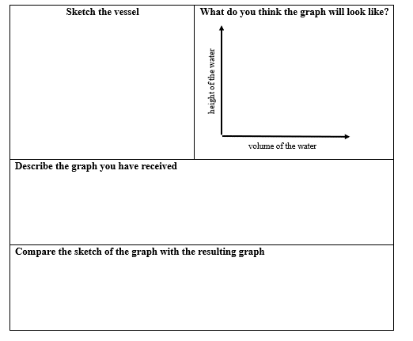 | 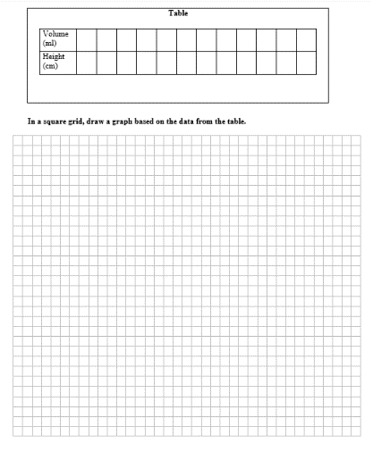

Sample worksheet

- Each group should try working with at least two different vessels. The worksheets for each vessel will differ in the total volume of water added, and in the amount of water added for each trial. The vessels include a cylinder-shaped vessel (linear growth), a vessel that tapers upward (the graph of the function is convex), a vessel that widens (the graph of the function is concave), and a wine glass with a stem (the graph does not start at the origin of the coordinate system), etc.
- The worksheets vary according to the total volume of the vessel the students are working with at the station (see figures below).

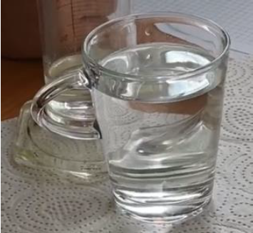 | 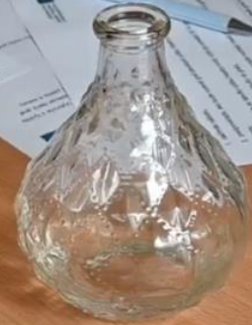 | 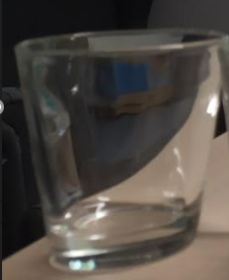
A | B | C
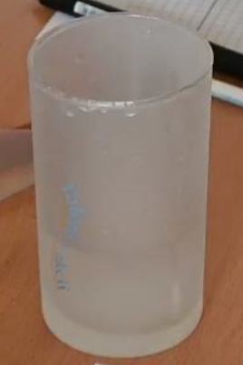 | 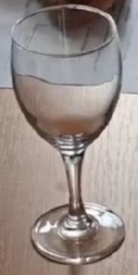 | 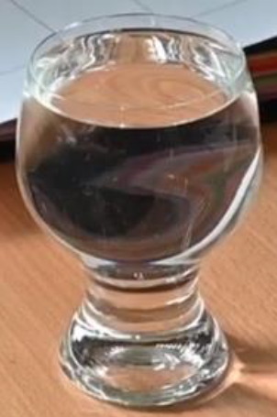
D | E | F
Vessels at each individual location

- At the end of the activity there will be a discussion with the students. We will sketch the vessels on the board, and the students who have worked with them will sketch the graph they have been given. Groups that had the same vessels can compare their results. Other possible discussion questions are:
  - Which graphs from the previous activity did you observe in your measurements?
  - What do these graphs have in common?
  - How would the graphs change if you gradually decreased the volume of water added?
  - When would the graphs of the function be decreasing?
  - Are each of the seven graphs from Activity 1 represented in your measurements?
  - Why weren’t any of the graphs constant?
Suggested aids, tools:
- A different vessel at each location
- A measuring cylinder filled with water in 5 ml increments
- Worksheets
- Paper towels
Estimated time: 30 minutes

Lesson 2

Elaborate/Evaluate
The teacher will assign each student a pair of graphs from the graphs shown below as follows: student 1 is assigned AB, student 2 is assigned CD, student 3 is assigned EF, student 4 is assigned GH, student 5 is assigned IJ, student 6 is assigned KL, student 7 is assigned AB, ...
Students who have the same pairs of graphs will later join to form one group.
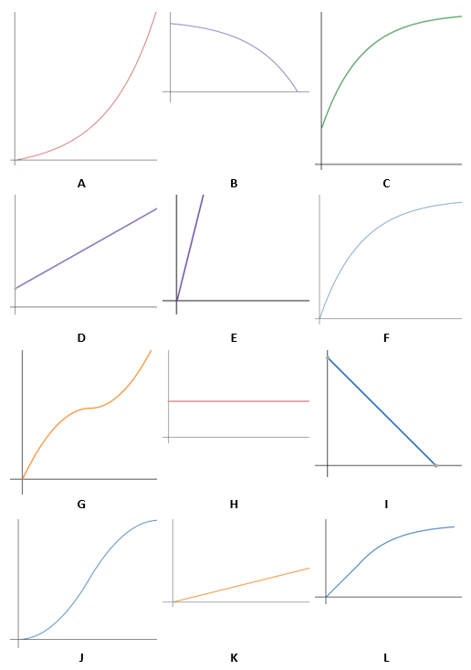

Activity 4
Each student will be assigned two images of graphs depicting the dependence of the height of the water level (y-axis) on the volume of water poured into the vessel (x-axis). Sketch what a vessel corresponding to your graphs might look like.
- Students independently solve the problem in the activity.
- During the activity, the teacher prepares stations for each pair of graphs for the next activity.
Suggested aids, tools:
- At least three copies of each image (preferably four copies) so that a minimum of three students can work at each station.
- Clean paper for each student to sketch the vessels.
Estimated time: 10 minutes

Activity 5
Students will stand at the station indicated by the letters on their graphs. Those at the station will compare their drawings of the vessels. What did you find?
- Students stand at the stations with their sketches of the vessels, compare and discuss them, and then come to an agreement as to what the final sketch should look like.
- Before carrying out Activity 5, the teacher prepares sketches of the graphs that the students have been given on the board.
Estimated time: 10 minutes

Activity 6
Sketch the vessels according to the agreement made at the stations.
- After the students have agreed and sketched the vessel on their worksheets, one student from each station sketches the vessel on the board. If the students have not agreed, then multiple students come to the board, and everyone sketches the vessel they think is correct.
- We discuss the solutions together with the whole class. Possible questions for discussion are:
  - What was the final sketch you agreed on, and why?
  - Did everyone in the group have the same vessel sketch?
  - Justify your sketch of the vessel.
  - If someone had a different vessel, what was different about it? What would the corresponding graph look like?
  - Does the volume of the vessel matter?
Estimated time: 20 minutes
Before the next activity, the teacher will again fill the prepared vessels to about half their height with water.

Activity 7
We poured the same volume of water into two vessels - blue and green (see images).
The images contain graphs drawn by the students, describing the dependence of the height of the water in the vessel on the volume of water poured into the vessel. Which student is correct, and why?
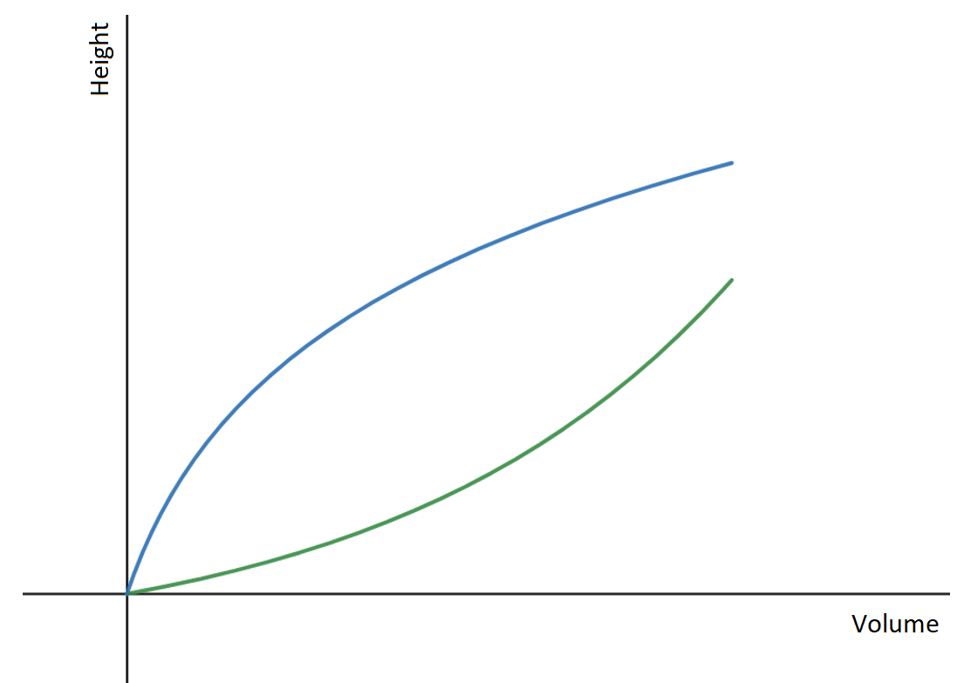 | 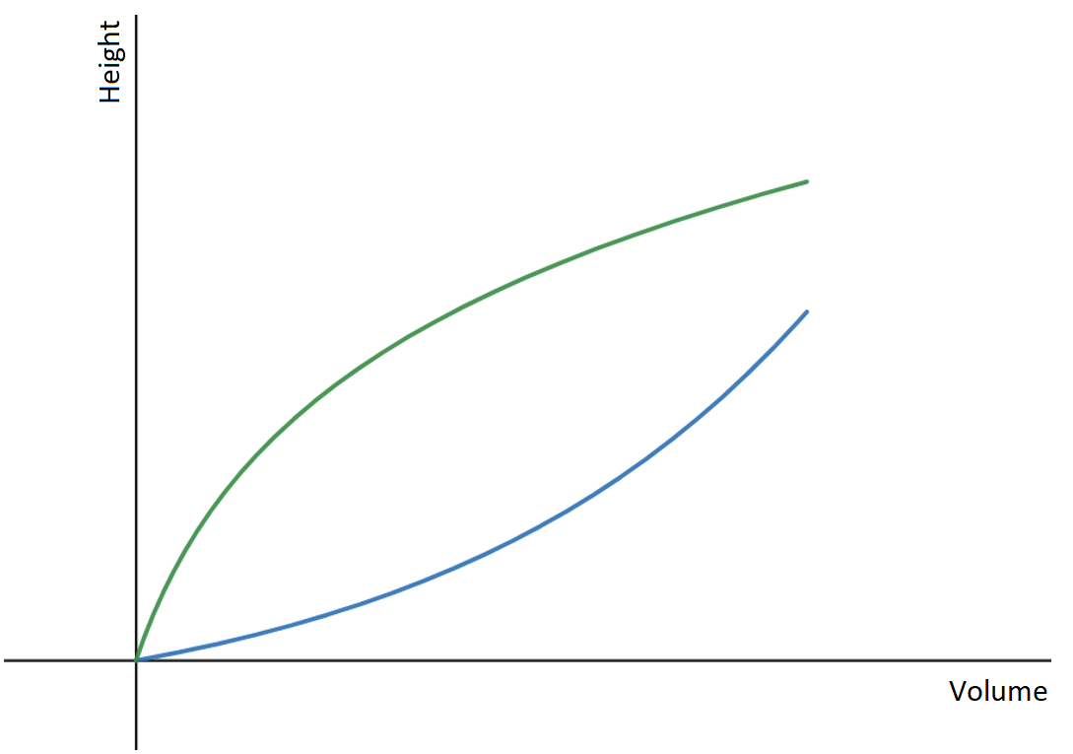
Ann: As I show in the graph, the green vessel widens at the top, and the blue vessel tapers upward, and yet, there is the same volume of water in both vessels. | Brian: I think the opposite is true. The green vessel widens at the top, so the line doesn't go up as fast in comparison to the blue vessel, which increases more quickly as water is added.
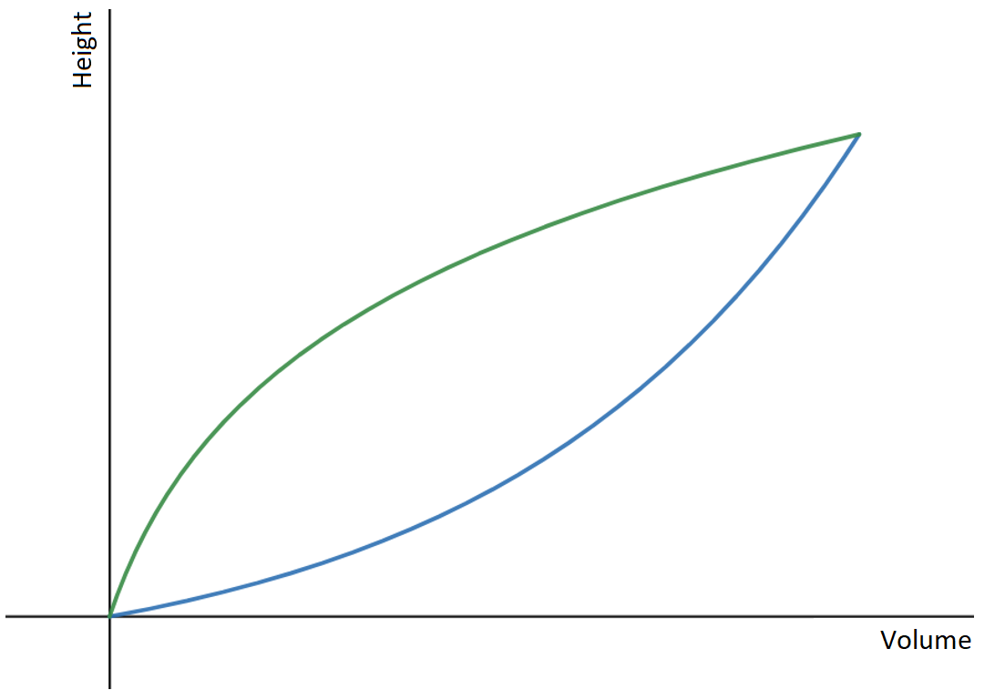 | 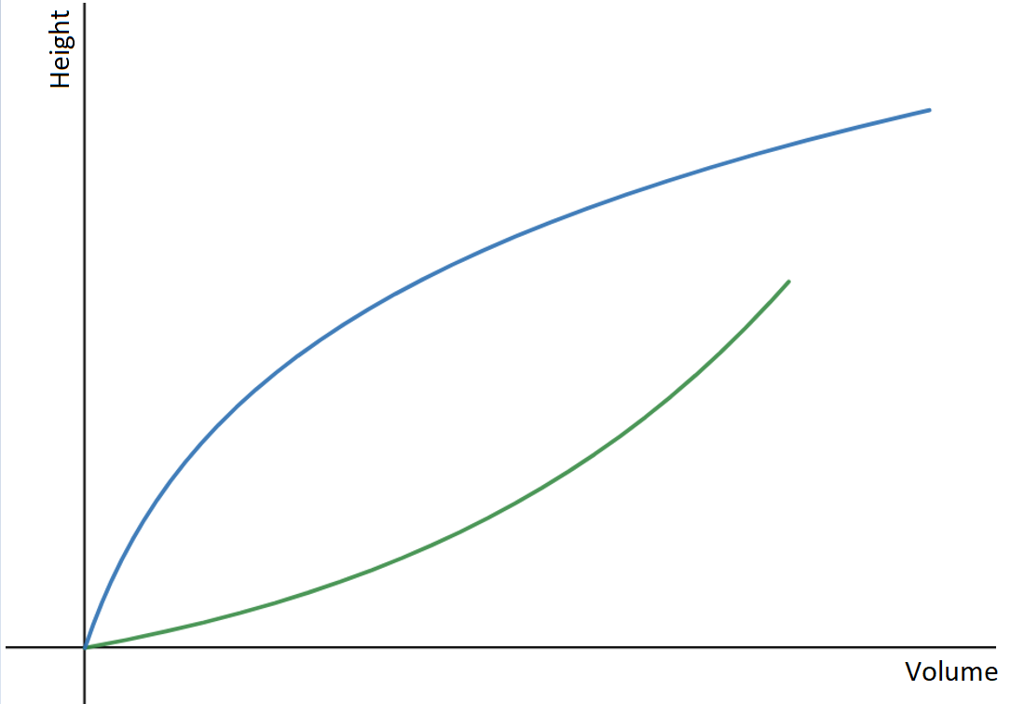
Emma: I think Brian is right, but the lines should end at one point, because we have just as much water in both vessels. | Philip: I agree with Ann, but we don't know at what points the lines on the graph stop.

- The aim of the activity is to find out if students are aware that the shape of the vessel affects the relationship between the variables studied, be able to explain and verify how it does so, and to check if they can relate the graph to a real-life situation.
- The correct answer is identified by Brian. Most often, students choose between Brian and Emma. They estimate that the graphs must connect since the same volume is added. They don't realize that in both cases the endpoint must have the same x-coordinate (volume), but that the y-coordinate will be different (height of the water).
Estimated time: 5 minutes

