Teacher Guide

Module: | Temperature
Teaching Hours: | 60 minutes
Grade Level: | Grade 7 & 8
Brief Description: | In this module, the arrow diagram representation is introduced and students renew their knowledge about representational changes between table and graph. Students examine the uniqueness of a functional mapping in the arrow diagram and coordinate system representations and switch between the representations. By using different representations of functional relationships, students become aware of their properties and learn to switch between them. In doing so, students distinguish between non-unique and unique mappings. To improve understanding and implementation, temperature data is represented in simplified form.
Design Principles: | Inquiry
 | Situatedness
 | Digital tools
 | Embodiment
Functional Thinking: | Input - Output
 | Covariation
 | Correspondence
 | Object
Learning Goals: | - Introduction of the function as a unique mapping.  - Recognize functions in different forms of representation.  - Check whether a situation/ representation shows a functional relationship or not.

Information for use:
- Link: https://www.geogebra.org/m/uka5kz4c
- Students can access the corresponding GeoGebra applet by scanning/photographing the QR code in the PowerPoint presentation and in the researcher's booklet (student handout).
References:
- Source temperature data: https://www.wetter2.com/europe/germany/baden-wurttemberg/stuttgart?page=past-weather#day=2&month=2 (25.03.2022)
- GeoGebra Researcher Assignment 1-5: adapted from https://www.geogebra.org/m/xgykmjxv (03/25/2022)

Lesson outline for the "Temperature" module
Section | Teacher | Students | Didactic-methodical comment | Required Material
Introduction  (10 min) | Teacher shows a graph of a real temperature trend and asks questions about the change in temperature throughout the day.  Other questions:  - During what time of year might the temperatures have been measured? (Feb 2017)  - What is the first value, what is the second value?  Next slide (3):  What is different here?  Focus on reversing dependency | S answer the questions and describe the graph. | Motivation through real-world example  Introduction temperature-time graph (correspondence aspect/ input-output aspect)  Whole class | Slides (2-5)
Introduction Exploration/  Research assignment  (5 min) | T explains the research assignment: "Today you will examine temperature data in different representations. You will use a GeoGebra applet for some tasks."  Explanation GeoGebra applet if necessary. | S ask questions if applicable. | Whole class | Slides (6,7), research booklets (student handout), tablets, GeoGebra
Exploration/ research phase  (20 min) | T observes and provides assistance if necessary. | S complete research assignments (handout) using GeoGebra applets.  S check their results independently. | Partner work  Introduction arrow diagram  Working with the coordinate system, table and arrow diagram as forms of representation  Changing between representations  Introduction unique mappings. | Research booklets, tablets, GeoGebra
Structuring & organizing knowledge  (5 min) | T assures students' knowledge of with the help of a memo box. The teacher uses the temperature context and visualizes the findings/ rule (memo box). | S read the memo box and fill in missing information. | Whole class  Function as unique mapping  Value pair  Function values | Slides (8-10), handout memo box
Checking  (5-10 min) | T shows graphs, arrow diagrams, and descriptions of assignments. | S apply their acquired skills, check representations for uniqueness/ identify functional relationships. | Whole class  Assessment | Slides (11-15)

Blackboard / Slides for introduction:
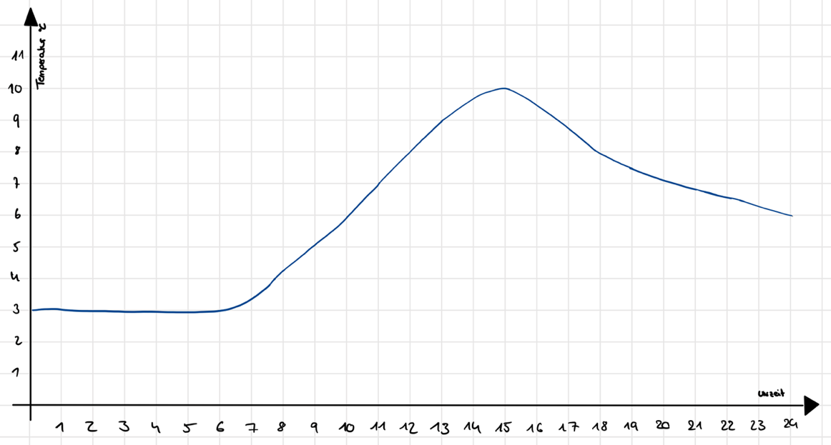
Temperature °C

Time

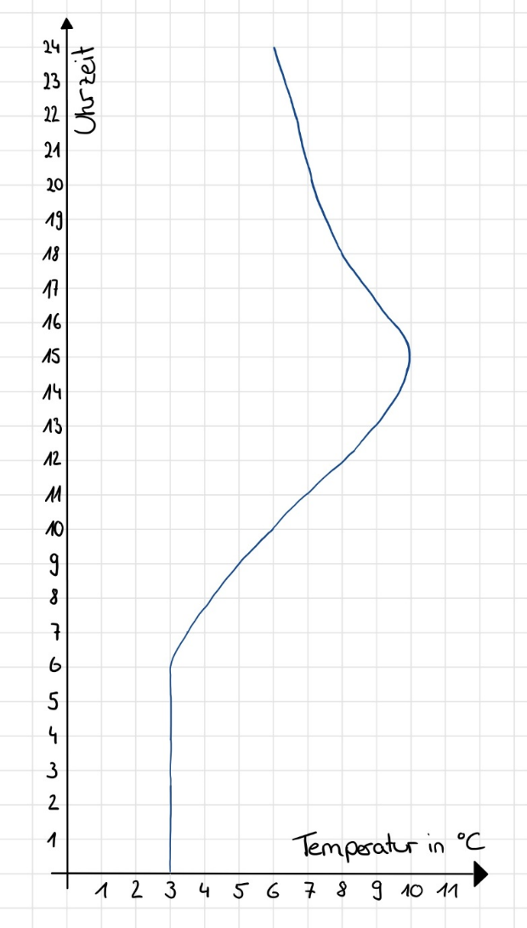
Time
Temperature °C
Memo Box:
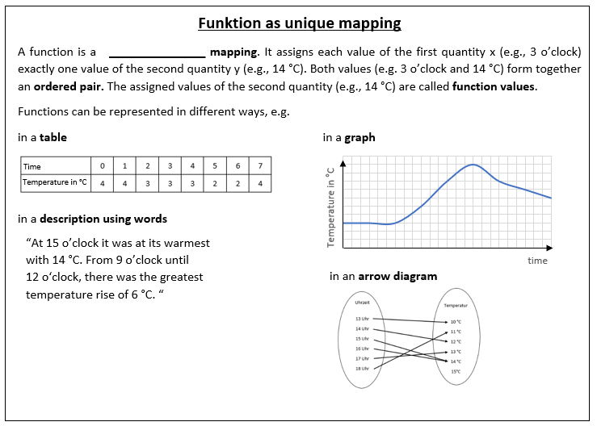
Solution Memo Box:
