Lesson Plan

Module: | Nomogram
Teaching Hours: | 150 min
Grade Level/Age Range: | 7-8
Brief Description: | In this module, students will explore a new mathematical representation for functions, named Nomogram, with their body movement. Nomogram is consisted with two number lines and arrows. With the light ray contexts, nomogram introduces different functional relations which are the bases of the pure mathematics context in the subsequent tasks. The two number lines represent the domain and range of function respectively, and the arrows show how input vales are mapped to output values. The different attentional anchors are provided referring to input-output aspect (directions of arrows) and covariation/correspondence aspect (a moving point in the Cartesian coordinates).
Design Principles: | Inquiry
 | Situatedness
 | Digital tools
 | Embodiment
Functional Thinking: | Input – Output
 | Covariation
 | Correspondence
 | Object
Learning Goals: | - Students are able to interpret the meaning of an input or output relevant to the context of a problem.  - Students are able to find the output, when given the input, height, and vice versa when given a nomogram.  - Students are able to describe how functions work as input-output machine​  - Students are able to identify a function as a relation that pairs one input to exactly one output.  - Students are able to explain how sets of numbers are related to each other  - Students are able to describe the relationship between the dependent and independent.  - Students are able to use both function graph and nomogram to represent functions

Activities

Introduction
Teacher introduces today’s topic: Nomogram with function and function graph
Teacher invite several students to solve the tasks in NWD in front of the whole class. Other students make a guess according to their observation and write down their answers in the handout.
Option: For the classroom with available tablet, it’s possible to let student collaborate in pairs or groups. Teacher invites students to describe their exploration process and summarizes the conclusion after each type of tasks.
Tasks available here:
- Context-based: Embodiment (dwo.nl)
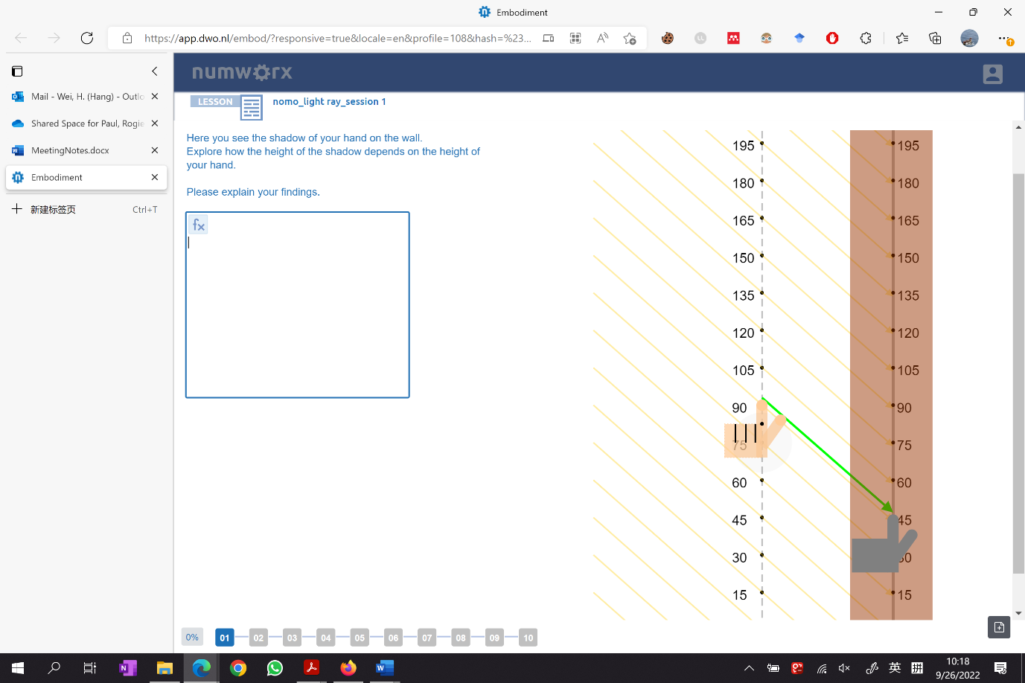
- Pure nomogram: Embodiment (dwo.nl)

Light ray context and Nomogram
Using light ray contexts (parallel and point source light rays), let students explore the relationship between the positions of real-life objects and their shadows which can be represented by nomogram and function rules (formula). When finding the output/input with given input/output, students realize that input-output values always appear in pairs, like the shadow and hand. In discussing how shadows change when the position of mosquito change, students realize that changes in output (shadow) correspond with the changes in heights. By using function rules (formulas) and nomograms to represent the relationship between two variables, students’ understanding of function is promoted.
Suggested tools/materials/:
- NWD Nomogram
- Handout
Estimated duration: 50-60 minutes
Basic nomogram
Students are asked to move the two points simultaneously and try to keep the arrow green. Let students describe their motion and the relationship between the two hands. And no need to think about mathematics and numbers in these tasks. They only need to experience how to move their fingers/hands and get familiar with the movements to better explore the following tasks
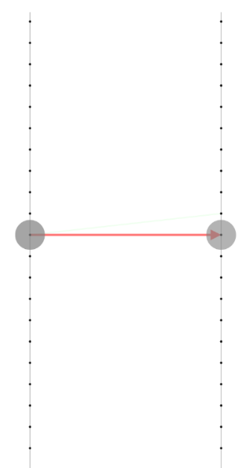
Suggested tools/materials/:
- NWD Nomogram
- Handout
Estimated duration: 20 minutes
Basic nomogram with numbers
Students are asked to find out the rule that can keep the arrow green by moving the two points on the two number lines freely. The rule can represent how the numbers on the left line are mapped to the numbers on the right line, which are also the domain and range of function. Teacher asks students to feel the covariation between their two hands (the two variables) when moving the tow points together. Teacher summarizes some typical moving patterns for functions. Students will be familiar with this ‘new’ representation of a function and then explore the following tasks.
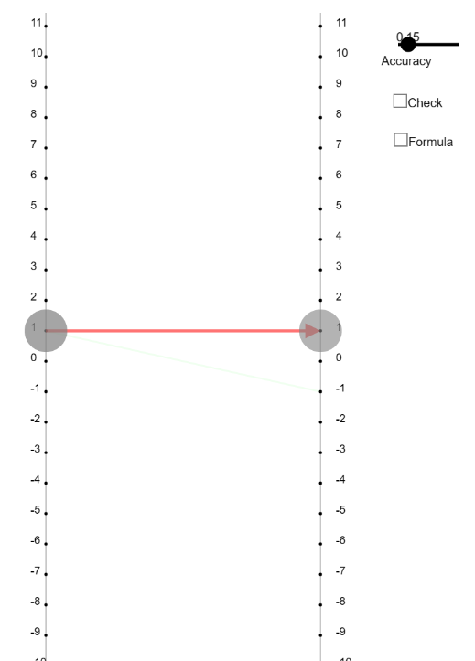
Suggested tools/materials:
- NWD Nomogram
- Handout
Estimated duration: 20 minutes
Function graph and nomogram
The graph of a function is given in this task. And there is another point in coordinates. When graphing the nomogram, teacher can ask student to find the relationship between the point and two ends of a nomogram. Teacher can emphasize the connection between the different mathematical representations of function (graph & nomogram) after this task.
Suggested tools/materials:
- NWD Nomogram
- Handout
Estimated duration: 30 minutes
Nomogram and function graph
The nomogram of a function is given in this task. When graphing a function, the nomogram will become green if the point is in the right place. Teacher can ask student to pay attention to the sets/pairs of number, which represent the input values and output values.
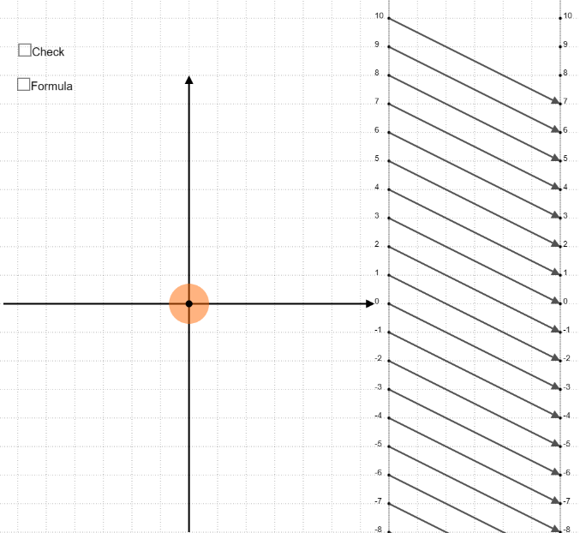
Suggested tools/materials:
- NWD Nomogram
- Handout
Estimated duration: 30 minutes

