|  |
| --- |
| **Lesson Plan** |

|  |  |  |  |  |
| --- | --- | --- | --- | --- |
| **Module:** | Light intensity graphs | | | |
| **Teaching Hours:** | 60-90 min | | | |
| **Grade Level/Age Range:** | Grades 7-9 (13-15 years old) | | | |
| **Brief Description:** | The aim of this module is to develop a qualitative understanding of functional relationships at the pre-definitional stage, particularly to develop covariational reasoning and shape the intuitive understanding of the notion of function and function graphs.  Students create and explore graphs (of functions) using embodied experiments. Using their smartphones with PhyPhox software, they are involved in the experimentation – they change, through hand movement, the light intensity, they investigate it, mainly through the real-time graphical interpretation on the screen, they can also interpret the values of the measured light intensity.  The students have the opportunity to create and observe many functions with different graph shapes, to try to move hands in order to ‘produce’ movement as described by the provided graphs in real time, as well as interpret and work with graphs.  The module leads to an intuitive understanding of the formal definition of function. Due to the context of measuring the light intensity and the “impossible graphs” discussion, students, in a practical way, independently discover the conditions for the definition of a function and are able to distinguish between graphs of functional and non-functional relationships, all at the pre-definition stage. | | | |
| **Design Principles:** | **Inquiry** |  |  |  |
| **Situatedness** |  |  |  |
| **Digital tools** |  |  |  |
| **Embodiment** |  |  |  |
| **Functional Thinking:** | **Input – Output** |  |  |  |
| **Covariation** |  |  |  |
| **Correspondence** |  |  |  |
| **Object** |  |  |  |
| **Learning Goals:** | * **Meaningful:** Building the students’ intuitive knowledge based on the experiment with representations of various continuous functions, from experiment to graph and vice-versa * **Embodiment:** Building the understanding of graphs and the experience of producing graphs by moving hands, observing in real time, and analyzing the effect of hand movement on the shape of the graph, as well as reproducing some of the provided graphs through hand movement * **Inquiry based learning:** Discovering: * graphical interpretations of light intensity changes over time   - functional and non-functional relationships at the pre-definition stage   * **Digital:** PhyPhox (free software), the students’ smartphones. * **Didactical phenomenology:** The covariation of distance in time   during hand movement is mathematized.  **Learning goals:**   * Building, drawing, analyzing, and interpreting graphs of various continuous functions * Coupling hand movements to their representation as a curve in the graph (both directions: from hand movement to graph and from graph to hand movement) * Discovering - at the pre-definition stage in practice - the conditions for defining the concept of a function | | | |

|  |
| --- |
| **Activities** |

**Suggested tools/materials:**

* Mobile phones with free application PHYPHOX installed,
* desktop computer / laptop with web browser,
* projection screen,
* projector,
* spreadsheet,
* handouts

**Estimated duration:** 60-90 minutes

The lesson is based on the use of the students’ mobile devices and the free PhyPhox app.

Below we outline how to use the app and how to display the app view on a projector so that it is visible to all students. Figure 1 shows the PhyPhox window.

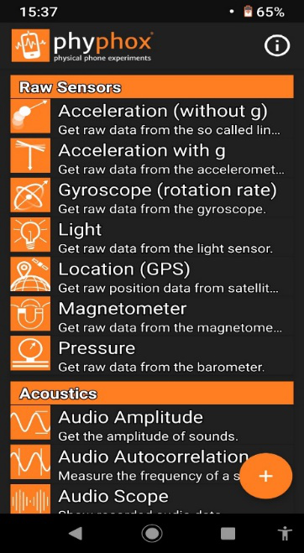  
**Figure 1. Application window**

We select the Light option.

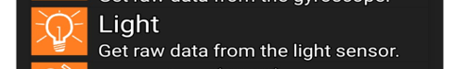

**Figure 2. Chosen option: Light**

To share data from the phone on the projection screen, we select the top menu on the right (see Figure 3).

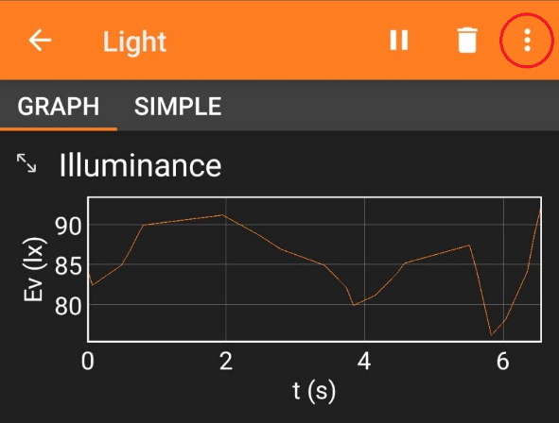

**Figure 3. Example**

*Then we select the "Allow remote access" option highlighted below in the application (Figure 4).*

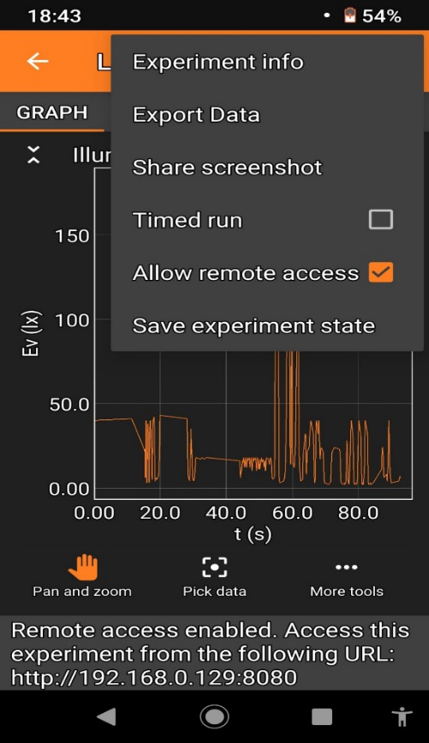

**Figure 4. Example of configuration for projection in classroom**

Enter the address provided at the bottom (Figure 4) of the application in the address bar of a web browser on the computer connected to the projector. Remember that the phone should be connected to the same WiFi network as the computer. If there is no WiFi network in the class, enable the hotspot on the phone and connect the computer to this network. We will use a light sensor covered by a hand to register light intensity changes over a period of e.g. 35 seconds, display and analyse these changes on a graph created in the application on the projector screen in the classroom.

Engage

We start the measurement. A chosen student moves their hand slowly over the phone (distance 1 to 15 cm) for e.g. 35 seconds, and PhyPhox registers the changes in y-axis illumination as a function of time t.

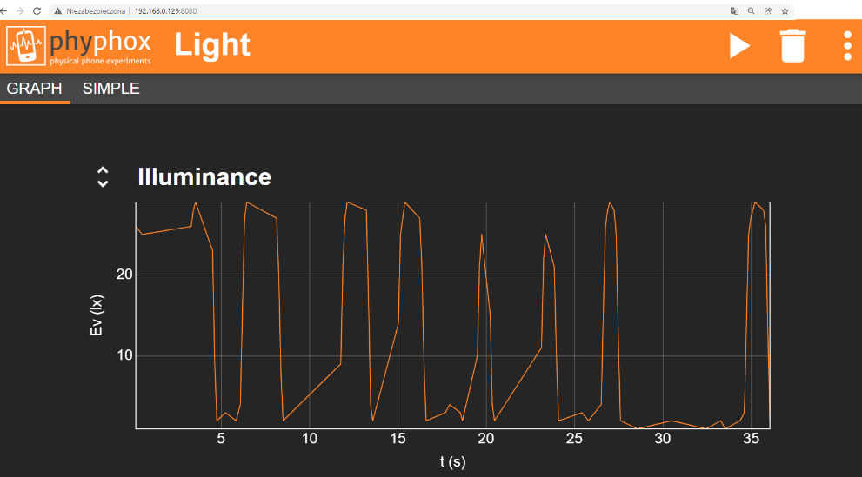  
**Figure 5. Application window during measurement visible on computer/ projection screen.**

The next phase of the lesson involves students experimenting freely and noticing different relationships. Students answer the following questions:

* What does the graph look like when you bring your open hand closer, for example at steady speed, to the sensor, increasingly blocking the access of light?
* What does the graph look like when you move your hand away from the sensor, for example at steady speed?
* How does the graph change as your hand movement gets progressively faster or slower?
* What happens when you stop your hand at a certain distance, partially obscuring the light sensor?
* What happens when you stop obscuring the light sensor? What if you cover it completely?

Engage / Explore

Each student tries to generate a graph similar to the one created on the projector with another student (Figure 5). Students move their hands over their own smartphones with the “Light” option selected.

Explore

Student assignment (same as in the student handout).

Students work individually on their smartphones. Each student has to move their hands in such a way as to generate the given shapes:



**Figure 6. Examples of graphs to produce using LIGHT option in Phyphox.**

Students save the results of their work as screenshots. The teacher individually, selectively checks the work of the students who report their screenshots.

Engage/ Explore / Evaluate

Student assignment (same as in the student handout).

Students work in pairs.

Each student has to sketch their own graph of light intensity in time on the provided worksheet, making an interesting and original shape (different from Figure 5 or Figure 6). They show it to their friend in pairs. The classmate's task is to recreate it in the app.

The student who invented the shape judges whether the task was done correctly.

The student who creates it, assesses whether the task can be done.

At the end of the activity, students report shapes that cannot be recreated. The teacher discusses them with the students and students give reasons for their unfeasibility.

Explore

Student assignment (same as in the student handout).

If none of the impossible shapes appear or shape no. 5 and/or no. 6 do not appear, the teacher provides these examples for discussion:

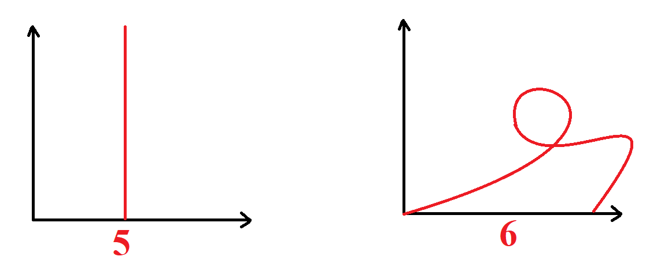**Figure 7. Examples of graphs which cannot be produced using LIGHT option in PhyPhox.**

Students collect and express their reasons.

Students discover that, in these graphs, time is on the horizontal axis, therefore you cannot go back in time (no.6), nor can you achieve infinite measurements in one instant (no.5), or even more than one (informal discovery of the second condition for the definition of a function – “there is exactly one function value”).

We also note that at any given moment there is a certain intensity of light that we can determine and measure, i.e. the graph of light intensity over time will be visible all the time. (informal discovery of the first condition for the definition of a function - "for every argument from the domain there is some value").

Explore

Student assignment (same as in the student handout).

Analysis of a graph.

Teacher: - Let us read the recommended light intensity for the following activities.   
(Teacher displays the table and the graph on the projector)

|  |  |
| --- | --- |
| recognising facial features | 20 lx |
| carrying out simple activities | 50 lx |
| blacksmith shop, workshop/garage | 200lx |
| computer operation, office work | 500 lx |
| precision assembly, micro-mechanics, jewellery workshop | 1000 lx |

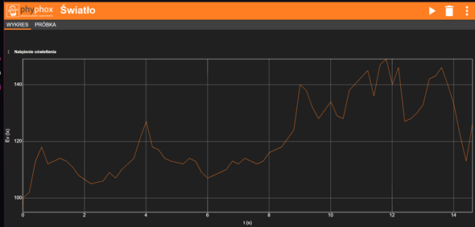

For the graph shown above, discuss the following questions:

1. Was the light intensity in the 6th second sufficient for office work?
2. When was the light intensity sufficient for jewellery work?
3. What was the highest light intensity during this measurement?
4. When was the light intensity sufficient to recognise facial features, but no longer sufficient for simple tasks?
5. What happened to the light intensity between seconds 4 and 5?
6. What happened to the light intensity between seconds 3 and 4?

Students justify their answers.

Explore

Student assignment (same as in the student handout).

Creating a graph fulfilling additional conditions.

Students are encouraged to make a graph in Phyphox that shows enough light for simple tasks, but not enough to work in a garage/workshop.

Teacher: What do you need to pay attention to in order to do this graph correctly? (Students create any graph such that the light intensity is between 50 lx and 200 lx)

Extend

Student assignment (same as in the student handout).

After completing the chosen measurement, we export its numerical data. The way to export data is given in Figure 8.

  
**Figure 8. How to select options for exporting raw data (e.g. for Excel)**

This allows us to continue working on the raw data. It should be noted that the data exported in such a format contains a very large number of pairs (x,y).

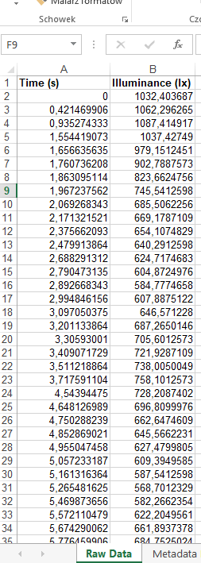

**Figure 9. Data series view in Excel**

Students thus become familiar with the second representation of a function besides the graph - a set of ordered pairs, and using digital tools (spreadsheet) make the transition from one representation to another.

We can pass such data series to the students or to a computer science teacher and ask students to draw their own graphs at home or during computer science classes (e.g. in a spreadsheet, see Figure 10).

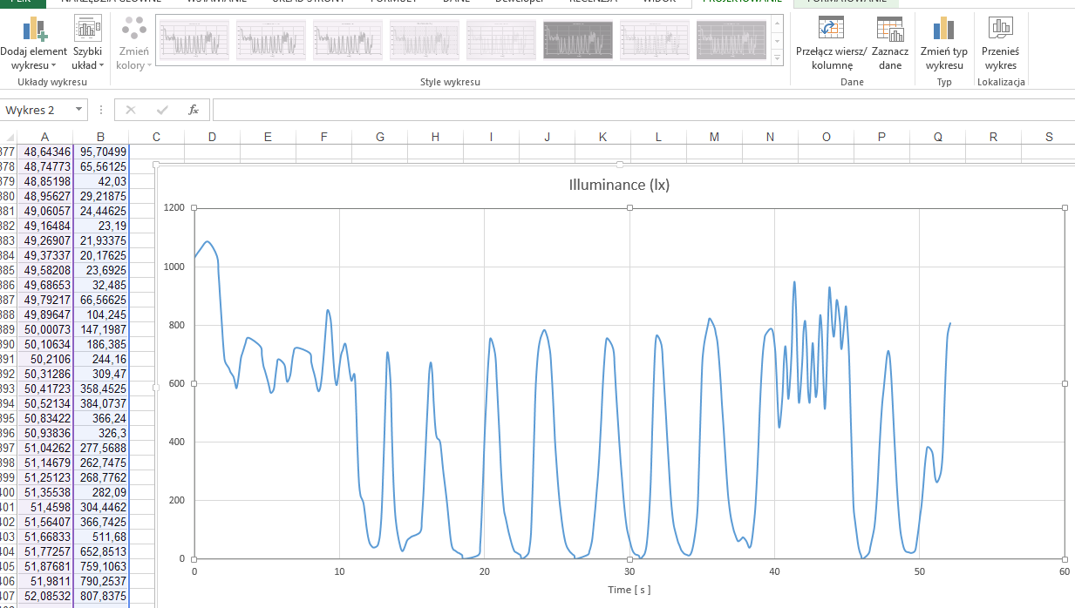  
**Figure 10. Data series and graph in a spreadsheet**