Lesson plan

Module: | How to move in coordinate system?
Number of hours: | 1 - 2 lessons
Vintage: | Grade 5-8
Short Description: | The lesson plan provides the space to develop an idea of the coordinate system, which is necessary for further work with functions.  It is a way for pupils to come into contact with the input-output aspect and its graphical representation - a point in the coordinate system.  The lesson is based on inquiry (students are not told how to notate the points in coordinate system, they are supposed to reinvent the necessity of agreement on the order, also need of separating character), built on embodied experience with moving points in coordinate system using digital tools. Situatedness is embedded in the situation of navigation among two students.
Principles of creation: | Inquiry
 | Situatedness
 | Digital tools
 | Embodiment
Functional thinking: | Input - Output
 | Covariation
 | Correspondence
 | Object
Prior knowledge: | - Mark natural numbers (or integers) on the number line.
Objectives: | - Explain what affects the position of a point in the coordinate system.  - Sketch the location of a point in the first quadrant of the coordinate system based on the coordinates.  - Read the coordinates of a point located in the coordinate system.  - Propose a method of recording the coordinates of points.  - Record the coordinates of points according to an agreed principle.  - Sketch the location of a point in any quadrant of the coordinate system. (Optional goal, if integers are known for students.)

Activities

Lesson 1
For this lesson you will need a tablet or other touch screed device (ideally one per student) and this applet: https://www.geogebra.org/m/aqzujujz. Teachers should work with it as a GeoGebra Classroom (click on "Create a class" on the top right and share the new link with your students). The teacher needs an account on geogebra.org.

Exploring

Activity 1. Triangle
Your first task is to find out how to move the vertices of the coloured triangle. When you figure out how they move, move the purple triangle to cover the black one.
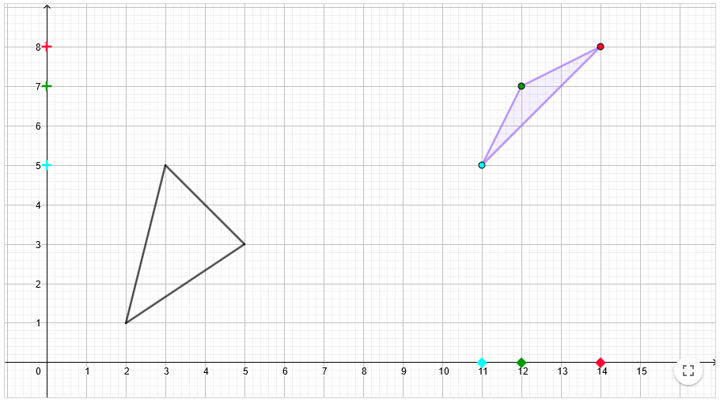
Describe how you moved the vertices of the triangle. Explain what their actual position depends on.
- Independent work:
Pupils try to work out how they can move the vertices of the purple triangle. Their position depends on the position of the same-coloured squares (coordinate $x$) and the plus symbols (coordinate $y$). If most pupils do not know how to proceed, the teacher can call on the pupil who has figured out how to move the coordinates to explain it verbally to the others.
- Group work:
In pairs or in groups of three, students compare their solutions and formulate an answer to the question posed after the problem. The teacher does not suggest own formulation. It is important at this stage to be sensitive to the language that is natural to the pupils.
- Whole group discussion: How did it turn out? Was it difficult? How did you move the vertices? At this stage, a common language can become clear. The teacher can allow informal language; we don't need to use words like "coordinates" and "axes" yet.
Estimated time: 7 minutes

Activity 2. Quadrangle
Practice what you have learned in this exercise. Move the coloured quadrangle to the quadrangle marked in black.
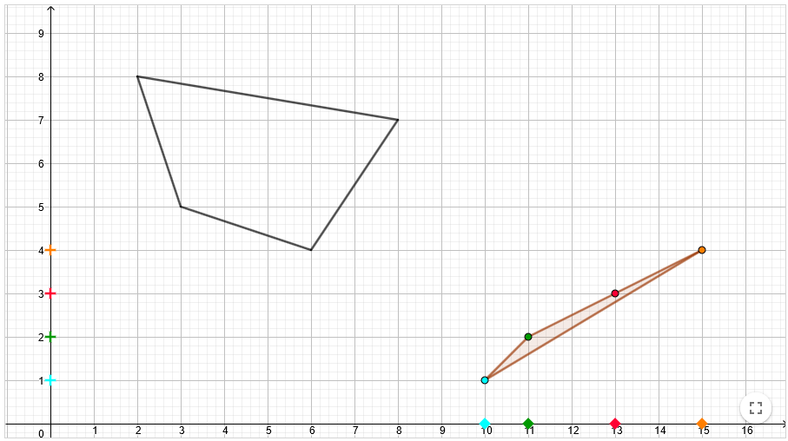
- Pupils move the vertices of the quadrangle, the teacher notes how they approach the problem. If a "irregular" (“butterfly”) quadrangle appears, the teacher can use this for discussion about quadrangles.
Estimated time: 3 minutes

Activity 3. Navigation
Now draw your own quadrangle. Don't show it to anyone yet.
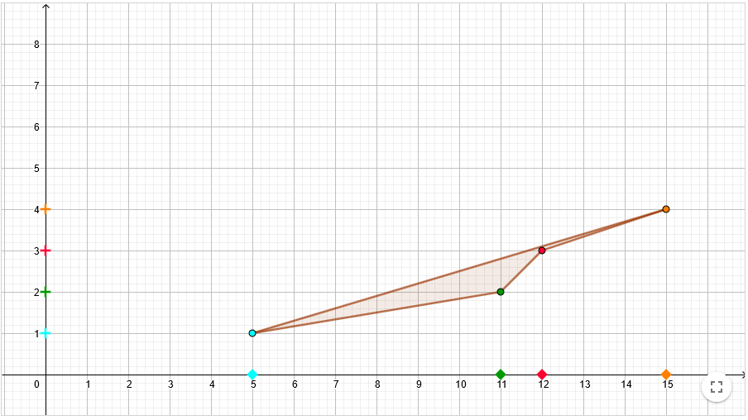
In the next task, you will guide your classmate to draw exactly the same quadrangle as you. Write down where you have placed each point.
Blue Point: Orange Point: Red Point: Green Point:
Now listen carefully to your classmate's instructions and draw the same shape as he drew. Then swap the roles.
- The teacher will explain what is going to happen and make sure that everyone in the class understands the procedure. After, they form pairs of pupils.
- Independent work:
Pupils draw their own quadrangles and record the positions of the vertices. In the case of one tablet for a pair - one draws and writes down their vertices, then the screen is adjusted so that only the notation and the space to draw the quadrangle is visible.
- Whole class discussion (if necessary):
If too many pupils are struggling with writing, other pupils can share their ideas. But if most students have their own system (more or less efficient), skip the discussion at this point. At this stage, the teacher does not impose his or her method of notation. Keep in mind that the symbol must symbolize a particular experience.
- Working in pairs:
Pupils navigate each other and give feedback on whether their navigation was successful. At this stage, the teacher notes how the pupils navigate and what they have written in their Geogebra notebooks.
Estimated time: 15 minutes

Explanation
Working together:
The teacher draws his/her own quadrilateral and asks the selected 4 pupils to come and navigate the rest of the class. He/she will make his/her selection of pupils based on his/her observation of the previous activity. Different notations should be written on the board. Make sure the inverse notation $\left[y,x\right]$ appear on the board, if any of kids used it. Then discuss the differences and which notation is the most effective. How can we make it even more efficient and faster?
Concerning abstraction of notation, go only as far as it is relevant at the moment. For example: $M=\left[2,3\right]$ may be too abstract, but Blue = (s2, p3) may be OK. Over time, kids will want to shorten it. If the class is ready, we can introduce standard notation. However, we necessarily need to agree on the order in which we write the coordinates here.
Estimated time: 10 minutes

Elaboration

Activity 4. Negative numbers - triangle (optional problem)
OK! We've already learned a lot :) Let's try to go back to the beginning now. And make it a little bit harder. Again, overlay the black triangle with the purple one.
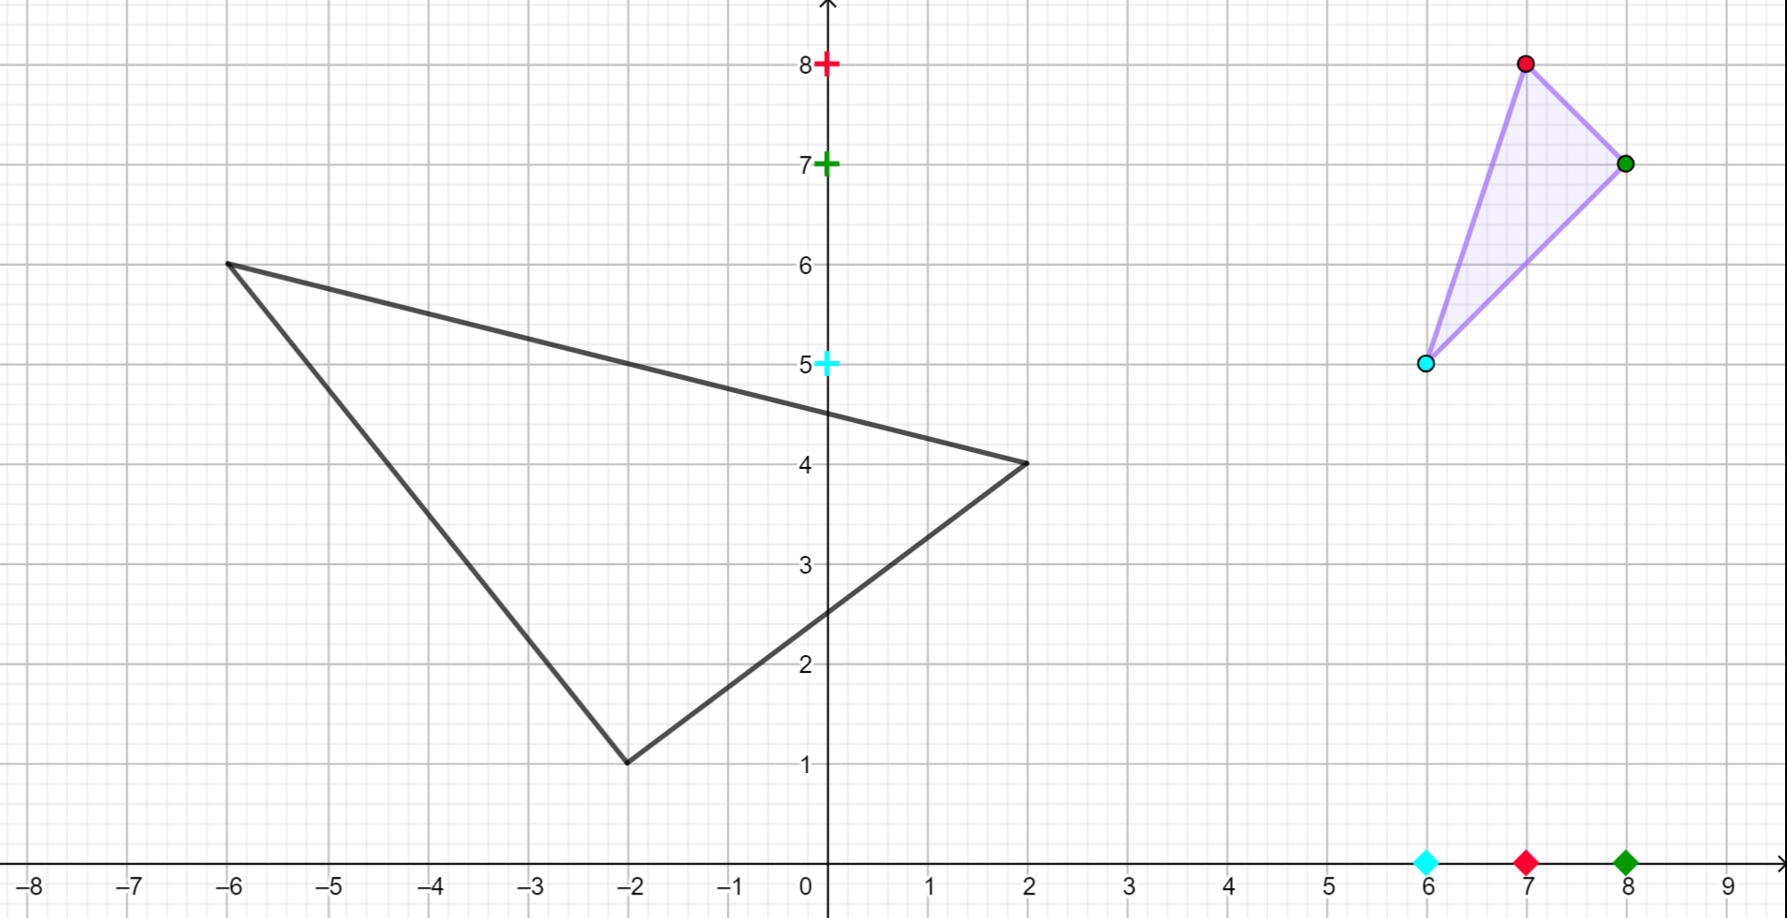

Activity 5. Negative numbers - quadrangle (optional problem)
Write this quadrangle using your coding:
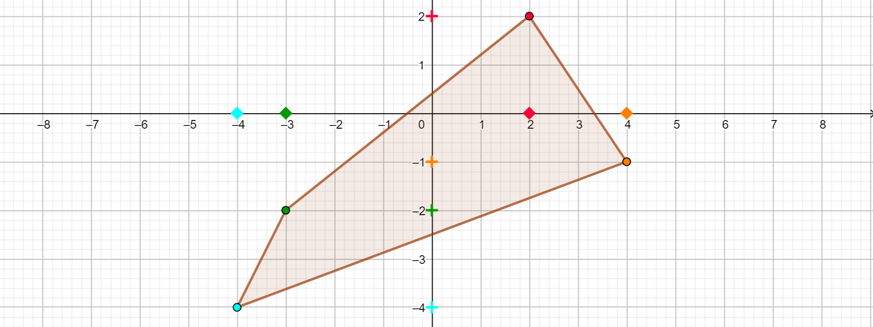
- If students will not struggle with integers, the teacher includes problems that focus on negative numbers. Once the problems have been solved, a discussion follows on how these problems are different from the previous ones.
- Again, there is room for refinement of the notation if the notation has not yet been sufficiently formalised in the explanation phase.
Estimated time: 10 minutes

Lesson 2
At the beginning of the next lesson, the teacher plays this game with the students, then continues to work with the coordinate system as part of their curriculum.

Evaluation

Activity 6. Game of Points
Now listen carefully to your teacher's instructions. After a short practice, you will play a game together.
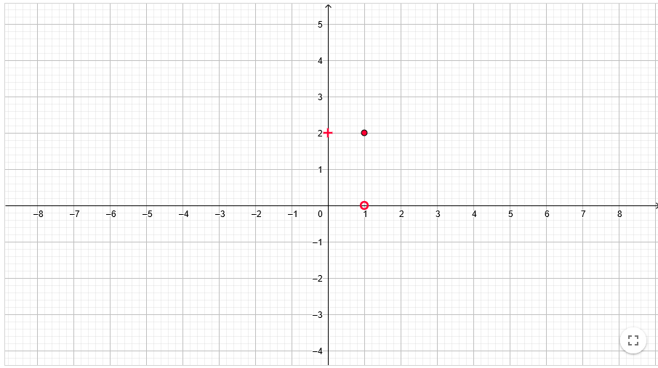
- Exercise:
The teacher will announce orally or in writing the location of the point. At this stage he/she may already use formal notation $B=\left[1,2\right]$ or use the statement such as: 'The coordinates of the point $B$ are 1 and 2.' The pupils are asked to place it in the correct place. It is at the teacher's discretion whether to use negative values. The teacher should specify several points that have at least one coordinate equal to zero. He should also use pairs of points with opposite coordinates to each other.
- The game:
The teacher will say that he hid the point somewhere on the screen. Pupils can ask yes/no questions to find out the location of the point. If anyone thinks they have already discovered the location of the point, they raise their hand. After the position is revealed, a pupil can hide the point. The teacher notices what questions the pupils ask, how they express themselves, can help them to refine their expression and negotiate more formal language in class.
Estimated time: 10 minutes

