Lesson plan

Module: | Change is change
Number of hours: | 2-3 lessons
Grade: | Grades 7-9  (depended on the country curriculum and expected outcomes)
Short Description: | The lesson plan is aimed at understanding the slope or at creating a good basis for understanding it in the upper grades. In terms of functional thinking, the dominant aspect is covariance, in which pupils focus on comparing the change on the $x$ and $y$ axes. The correspondence aspect is also supported.  We only work with the graph of a linear function, but we do not work with the linear function as such. Therefore, it is not necessary for pupils to know the concept of a linear function. It is sufficient for them to be familiar with geometric terms - point, line, distance of points.
Design Principles: | Research
 | Situatedness
 | Digital tools
 | Embodiment
Functional thinking: | Input - Output
 | Covariation
 | Correspondence
 | Object
Prior knowledge: | - Coordinate system  - Point, line, distance of points on the number line
Learning Objectives: | - The pupil can visually distinguish between the decrease and increase of a graph, and can describe the decrease and increase in his/her own words.  - The pupil visually distinguishes between the rate of decrease and the rate of increase of a graph. Can visually compare which graph of a linear function grows faster, can describe this in their own words.  - The pupil can numerically express the rate of change for a linear function from a graph.  - The pupil can fit the graph of a linear function to match a given rate of change.

Activities

Lesson 1

Engage and Explore
For this lesson you will need a tablet (ideally for each student) and this applet: https://www.geogebra.org/m/eg27k7jg. Best option is to open it as GeoGebra Classroom (click on "Create a class" on the top right and share the new link with your students). The teacher needs to have created an account on geogebra.org.

Activity 1. Draw a line
Click on "+". Then move it to trace the purple line as accurately as possible.
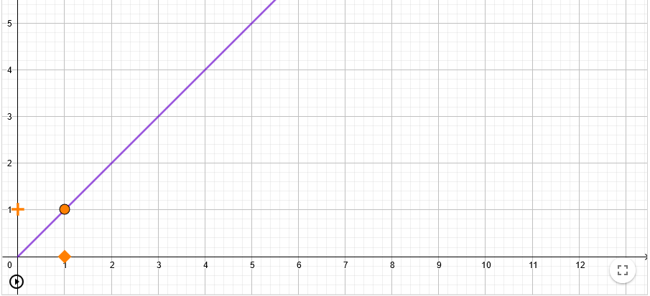
How would you describe to someone else the movement when you manage to draw the purple line? Compare the speed at which you move the "plus" with the speed at which the square moves.
...................................................................................................................................................
- With the first straight line, the pupils learn to move "correctly" - it is important to devote enough time for this. Do not hurry up too much. Students may not notice anything at first. The ideal technical solution is via a touch screen on a tablet or laptop, scrolling with a mouse is acceptable, scrolling with a touchpad has not worked practically.
- After the pupils have mastered the movement - when they are able to trace the half line accurately enough, the teacher will show the various exact pupil solutions and invite the pupils to formulate a "rule".
Now let's play the same game with a slightly different line. So again: Click "+". Then move it to trace the purple line as accurately as possible.
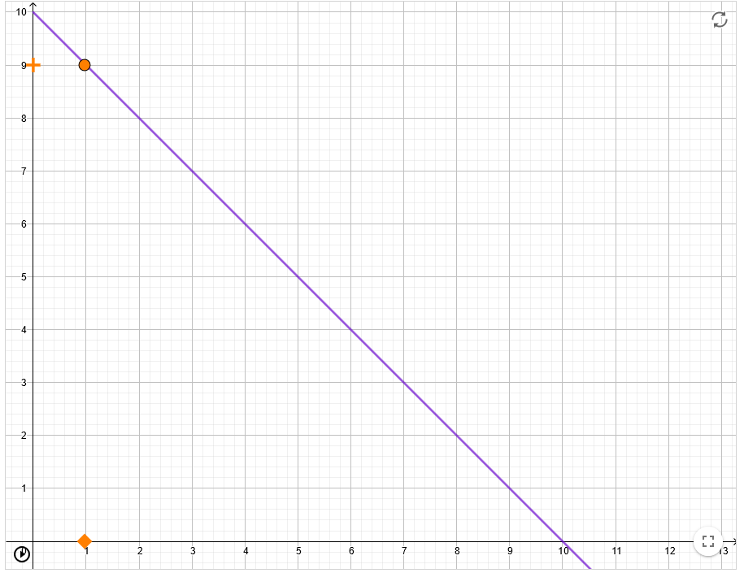
How would you describe to someone else the movement when you manage to draw the purple line? How is it the same and how is it different from the first picture?
...................................................................................................................................................
OK, one more line. So again: Click "+". Then move it around to trace the purple line as accurately as possible.
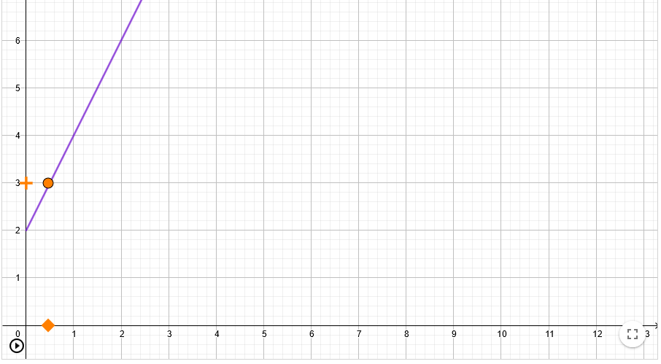
How would you describe to someone else the movement when you manage to draw the purple line? How is it the same and how is it different from the first two pictures?
...................................................................................................................................................
And now the last one. So again: Click "+". Then move it to trace the purple line as accurately as possible.
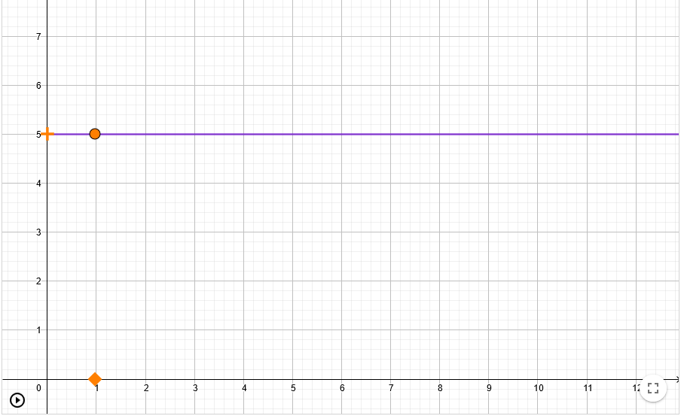
What did you have to do to stay on that line?
...................................................................................................................................................
- The teacher lets the pupils continue to work independently. It is important to encourage them to formulate their ideas. Teachers sometimes feel that the pupils do not know how to express their thoughts properly. That is why it is necessary to create opportunities for them where they will learn it.
- In the online environment of Geogebra classroom, the teacher keeps track of what students are writing and pays attention to the wording. He/She selects different formulation for the subsequent discussion. The discussion about the different formulation is the key element of this lesson plan.
Estimated time: 15 minutes

Explain
Joint discussion: what were the differences between the tasks? How is it possible that in the last task we did not move the "plus" at all, but still the graph was drawn correctly?
The teacher tries to work with the language of the class to capture how students name increasing, decreasing, and constant functions, how they name the rate of growth. If the classroom atmosphere is favorable, a thought-provoking question may come up: how might we numerically express the difference between the growth rates of the first and third graphs? How much or how many times faster does the third graph need to move compared to the first graph? But it is not necessary to solve this, we will come to that in later problems.

Elaborate
The teacher will open a new class in the GeoGebra for the activity at this link: https://www.geogebra.org/m/gvq4z5td

Activity 2. Trace the graph yourself
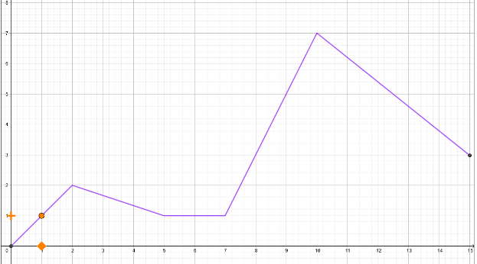
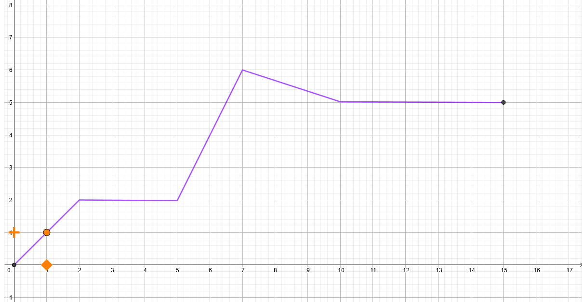
Now it's going to be cool!!! Try to trace the first two graphs as accurately as possible. To start the graphic, click on the orange plus sign.

- Independent work:
Pupils try tracing the graphs, the teacher observes how they are doing in the online environment. He encourages them to try it several times until the result is relatively accurate.
- Joint discussion:
How was this activity different from the previous one? Which parts of the graphs were the hardest and easiest to draw? Because of what?

Activity 3. Trace a graph in pairs
Trace this graph in pairs: one will navigate and the other will move the "plus". If you are the one who draws, close your eyes.
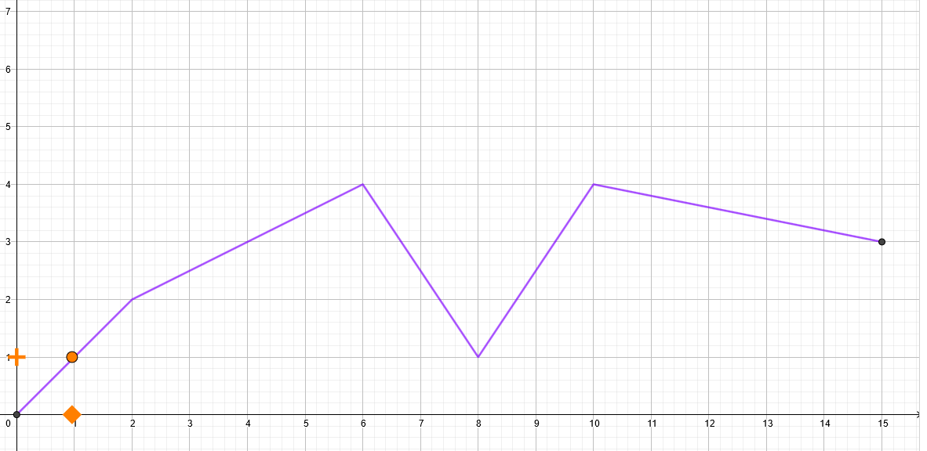
How was your navigation? What instructions did you use?
- Working in pairs:
Pupils try tracing the graphs, the teacher observes how the pairs communicate.
- Joint discussion:
Which was harder: navigating or drawing? Could we somehow refine the instructions as "faster" or "slower"? On which interval (section) did you move the fastest? Did you move faster on interval (6,8) or (8,10)?

Activity 4. Think first, then trace
Answer these questions before you try to sketch the next graph:
Questions:
- On which interval will you move faster? From 0 to 2 or from 2 to 4? Give reasons for your answer.
- On which interval will you move faster? From 0 to 2 or from 8 to 13? Give reasons for your answer.
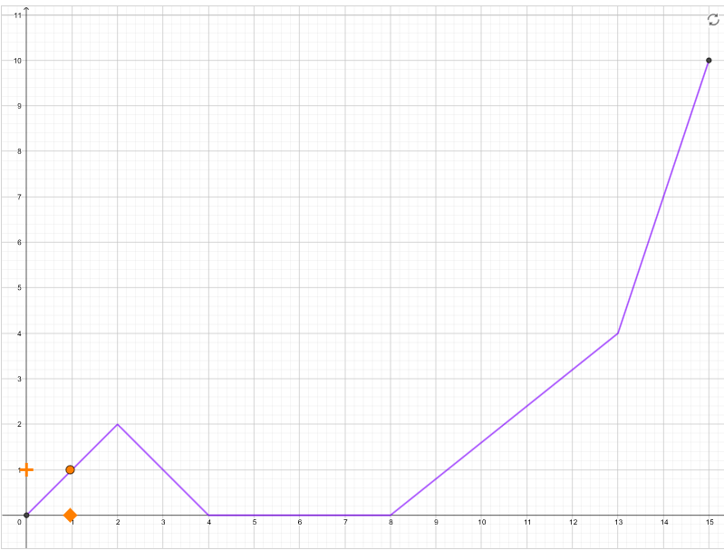
- Independent work:
In the GeoGebra classroom, the teacher keeps track of how the pupils answer the questions. He/she prepares different answers for the following discussion. Specifically, incorrect answers should be addressed.
- Joint discussion:
The teacher addresses each question and encourages different opinions to be discussed. He may expect some pupils to argue that downward movement is slower. He/she tries to get pupils to articulate their arguments.

Evaluate

Activity 5. Create a graph so that ...
You can create your own chart here. Use the slider to toggle on and off the display of the points you use to set the graph. Draw the graph according to the teacher's instructions.
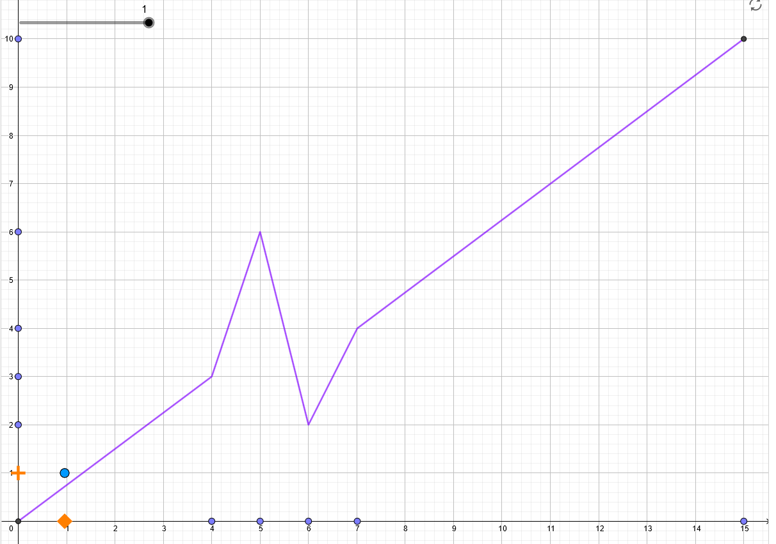
- draw a graph so that the plus sign moves upwards at the same speed all the time
- draw a graph so that the plus sign moves downwards at the same speed all the time
- draw a graph so that from 0 to 3 we move the fastest, from 3 to 5 and from 5 to 8 just as fast but in the opposite direction, from 8 to 11 we do not move and from 11 to 15 we move up only one piece.
- Group work / pair work:
Groups of students first try manipulating the graph. They then follow the teacher's instructions (written on the board) to adapt the graph.
- Joint discussion:
During the independent work, the teacher selects different solutions and then discusses their correctness with the class. At the same time, the teacher points out the variety of correct solutions.

Lesson 2

Engage
Joint discussion: we will come back to the navigation activity and to how the instructions could be more precise. Is there any situation in which precise navigation using numbers would be necessary? At the end of the lesson, we will navigate the computer to circle the graph.

Explore
The teacher creates a GeoGebra class using this link (click on the top right on "create class") https://www.geogebra.org/m/ggd6n5wm and shares the class link with the students.

Activity 6. Points on the line
Look closely at that purple line. If you were to trace it as in the previous activity. How would you have to move?
- All the time at the same speed.
- Upwards.
- Downwards.
- As fast as a square.
- Faster than a square.
- Slower than a square.
A: | B:
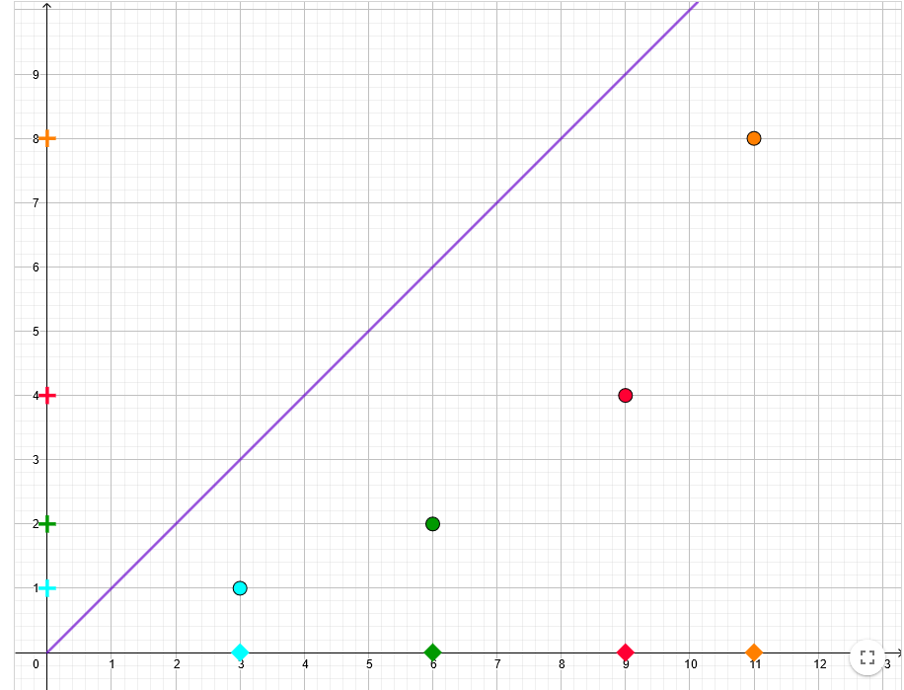 | 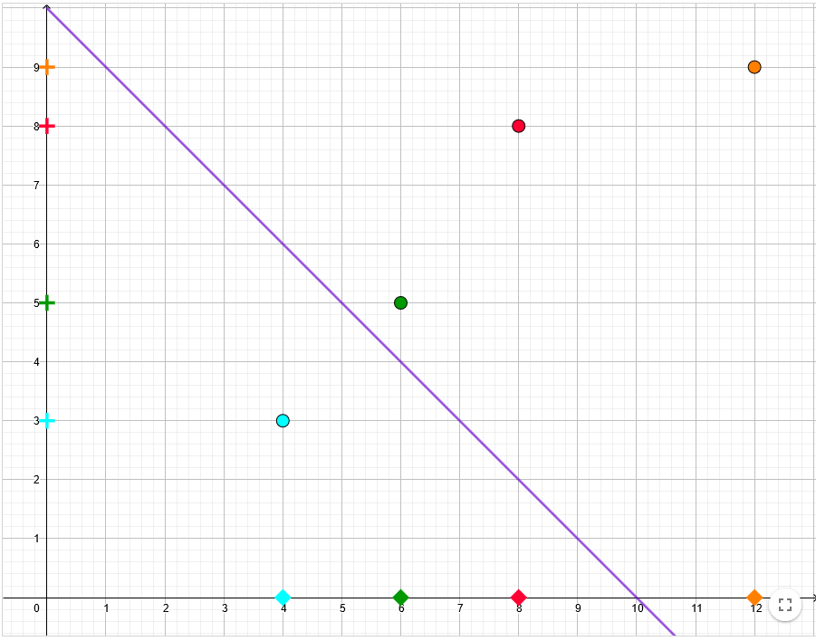
C: | D:
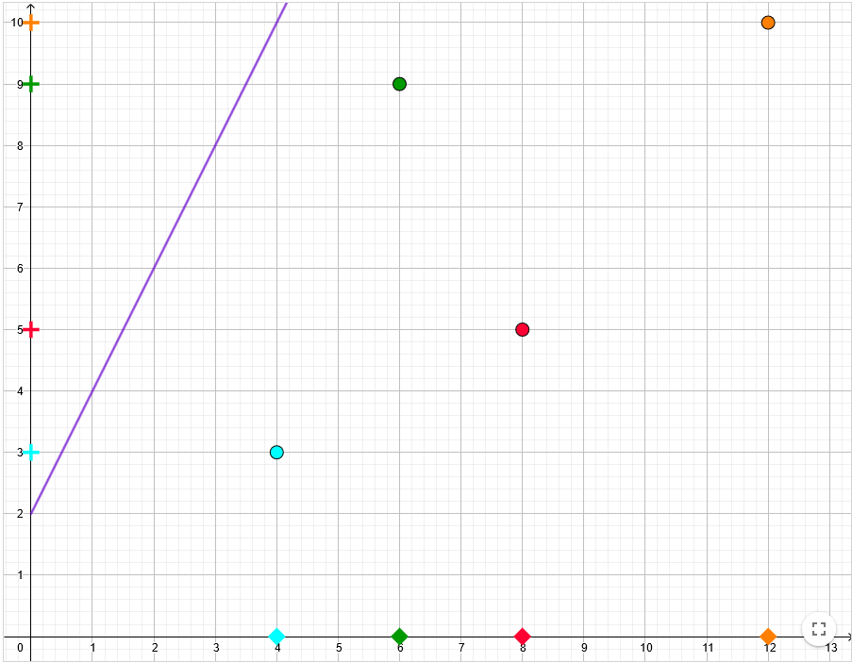 | 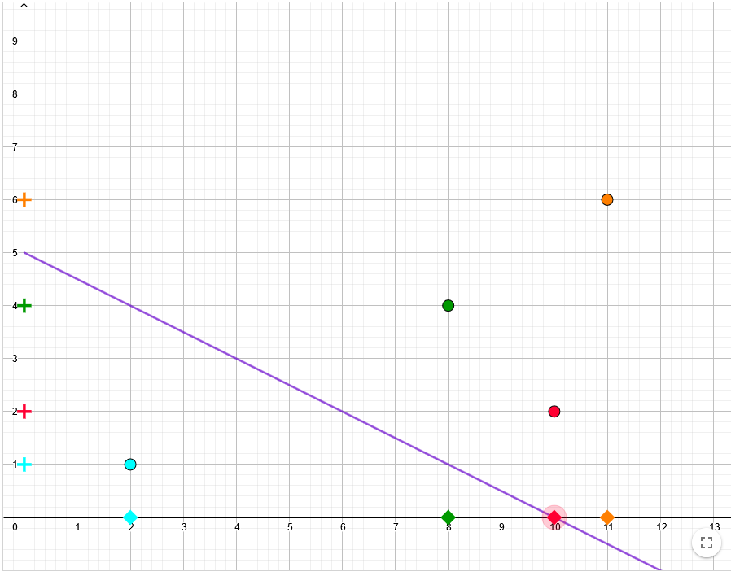

What is the distance between the blue and green squares?
What is the distance between the blue and green plus?
...................................................................................................................................................
What is the distance between the blue and red squares?
What is the distance between the blue and red plus?
...................................................................................................................................................
What is the distance between the green and orange squares?
What is the distance between the green and orange plus?
...................................................................................................................................................
Great! Now you're working like a real mathematician who notices a lot of details. Write now what you noticed when you wrote your answers to the previous questions.
...................................................................................................................................................
- Working alone / working in pairs
Pupils work independently. When taking notes, the whole class and the teacher can agree on a uniform system of note-taking. The system can be: e.g. $s: 2; p: 4$ The teacher certainly does not share his / her observations with them. Students should be encouraged to write down everything they noticed.

Explain
Joint discussion
The teacher continuously takes notes of the pupils' observations and brings up different ideas and formulations for discussion. Next, he asks questions about each graph: If I move 1 to the right on the x-axis, how much and in which direction do I move on the y-axis? If I move 2 to the right on the x-axis, how far do I move on the y-axis? ... If I move 10 to the right on the x-axis, how much do I move on the y-axis. He will use the same questions if the pupils have not noticed the regularity.
Conclusion of the discussion is the equality of fractions. Possibly, students might object it should by difference on the x-axis divided by the difference on the y-axis. In this case, we let them explore the numbers and naturally – faster motion should be described by the larger number (in absolute value). Therefore, we will divide ${Δy}/{Δx}$.

Elaborate
The teacher creates a GeoGebra class using this link (click on the top right on "create class") https://www.geogebra.org/m/pfskrkuq and shares the class link with the students.
The teacher motivates the pupils that now the real challenge is to navigate the computer to draw the graph as we have been doing - only much more accurately.

Activity 7. Adjust numbers
Rewrite the numbers in the boxes so that the orange dot draws a graph. Each number tells the speed and direction of movement as we have learnt in the previous activities.
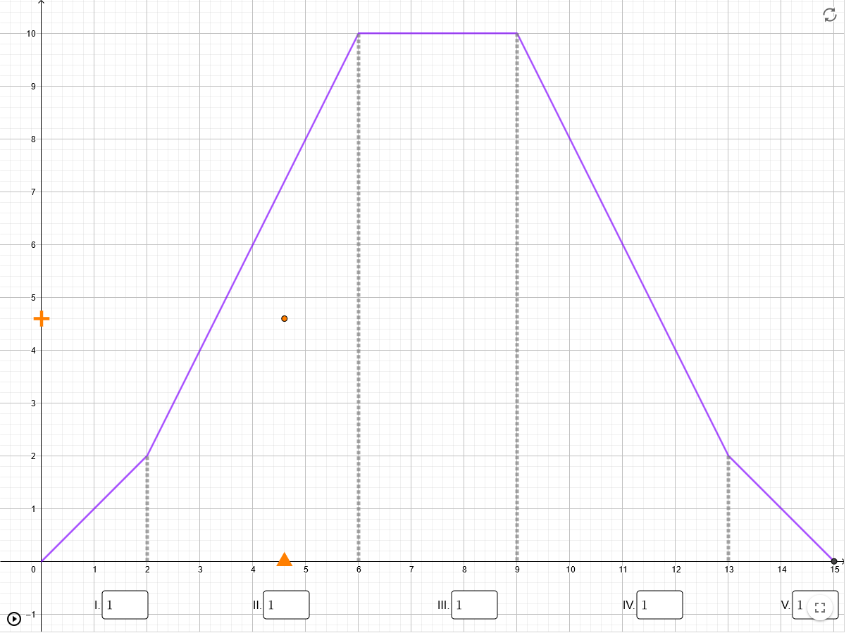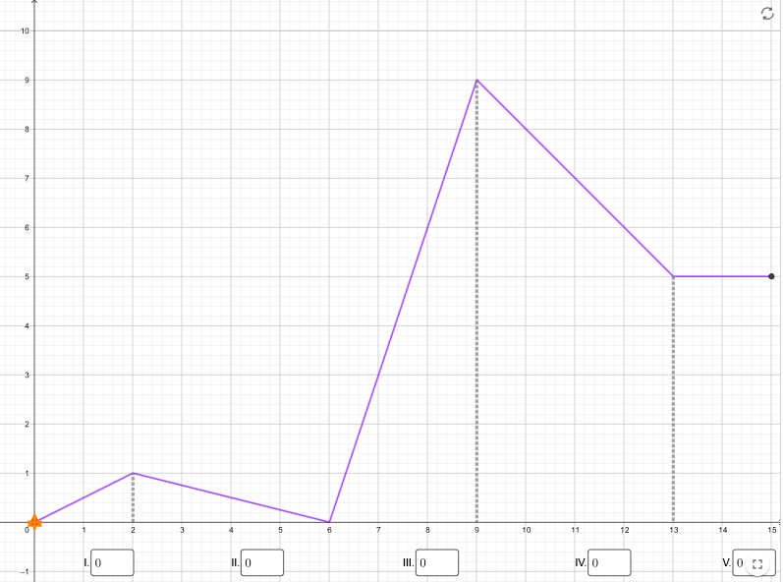
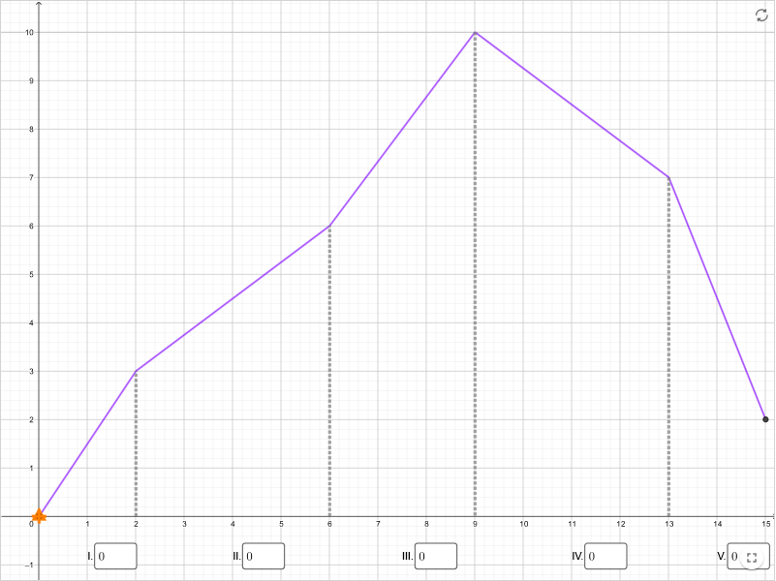
- Group work / pair work:
In pairs, pupils match the numbers to trace the graph. The teacher encourages them to test their estimations and to use fractions. To test the numbers more quickly, just move the triangle, there is no need to run the graphic.
- Joint discussion:
Is there another correct solution? What did you use to determine the correct numbers? What does 1 represent? What does "-1" represent? What does "2" represent? "What does "-2" represent?

Evaluate

Activity 8. Adjust a graph
Use the points on the graph to manipulate the graph. Edit it so that when you start tracing, the computer will trace your graph.
- 0,0,0,0,0
- 1,1,0,1, -1
- 2, -1, 3, -3/2,1/2
- ... other tasks are created by the teacher according to the level of the class
- If there is space (or if it is still needed)
The teacher creates a "sample" graph on the board - the pupils create the same graph in their applets and again match the numbers to the computer's tracing of the graph.
- Group work / pair work:
Groups of students first try manipulating the graph. They then follow the teacher's instructions (written on the board) to adapt the graph.
- Joint discussion:
During the independent work, the teacher selects different solutions and then discusses their correctness with the class. At the same time, the teacher points out the variety of correct solutions.
Attention! Applet does not draw any graph - it works only in the marked window from (0,0) to (15,10).

